ORGANIZATIONAL KNOWLEDGE GAP
INTELLIGENCE PLATFORM
SOFTWARE PROJECT DOCUMENTATION
Organization: Infosys
Project Duration: 4 Weeks
Individual Contribution: Backend Development

Submitted by N.SRIRANJANI

ABSTRACT

Abstract
The Organizational Knowledge Gap Intelligence Platform (OKGIP) is a full-stack enterprise application built to help organizations identify, quantify, and close skill gaps between what an employee currently knows and what their role requires. The system was developed over an 8-week engineering effort at Infosys and is organized into three delivery milestones: (1) authentication, employee profiles, and the competency framework; (2) a gap-analysis engine and a training-recommendation engine; and (3) mentorship/knowledge-sharing, learning-progress tracking, skills assessments, analytics dashboards, and an in-app notification system.
The verified technology stack is a Java 17 / Spring Boot 3.3.4 backend exposing a stateless REST API, secured with Spring Security and JSON Web Tokens (JWT) issued and validated through a custom filter chain, persisting data through Spring Data JPA/Hibernate to either an in-memory H2 database (default, development profile) or PostgreSQL (production profile, provisioned via Docker Compose). The frontend is a React 18 single-page application built with Vite, styled with Tailwind CSS, routed with React Router, and communicating with the backend through an Axios client that attaches the JWT to every request.
Functionally, the platform lets an employee record self-assessed skill proficiency, compares it against a configurable role/department competency framework, and computes a weighted gap and severity score per skill. These gaps drive a transparent, rule-based training-recommendation engine (internal academy and external providers), a generated multi-step learning path, and a mentor-matching suggestion list based on skill complementarity. Employees can enroll in training, update progress, and take multiple-choice skill assessments that are graded server-side and feed back into the employee's proficiency record, automatically refreshing their gap analysis. Manager and organization-wide analytics dashboards aggregate this data into department readiness scores, gap heatmaps, and training-effectiveness metrics, rendered with Recharts. An in-app notification inbox surfaces milestone, mentorship, and assessment events to each user.
This document distinguishes clearly, section by section, between functionality that is actually implemented in the supplied source code, functionality that is partially implemented, and technologies referenced only as future or proposed direction (for example, Redis, Kafka, Elasticsearch, OpenAI/LLM-backed recommendations, and containerized deployment of the application tiers themselves are not present in the codebase and are discussed only in Section 11, Future Enhancements). No test suite, CI/CD pipeline, or performance benchmark exists in the provided source, and this is stated plainly rather than assumed. Numerical outcomes not present in the codebase or supplied materials are not fabricated; where a metric cannot be verified, this document says so explicitly.
My individual contribution to this project was backend development: the Spring Boot application layer, comprising nine REST controllers, eight service classes containing the domain logic (in particular the gap-analysis, recommendation, and assessment-grading algorithms), thirteen Spring Data JPA repositories, thirteen JPA entities, the JWT-based Spring Security configuration, and the demonstration data seeder used to populate a working environment for the frontend team. Sections 6 and 7 of this document give this backend work additional technical depth, consistent with my role on the team.

PROJECT OVERVIEW & OBJECTIVES

2.1 Introduction
Large organizations struggle to answer a deceptively simple question: which employees are missing which skills, relative to what their job actually requires? Skills data is usually scattered across spreadsheets, LMS exports, and manager memory, and by the time a gap is noticed it has often already produced a delivery risk. The Organizational Knowledge Gap Intelligence Platform centralizes this problem into a single application: employees and managers get a live, quantified view of skill gaps, and the system turns those gaps directly into recommended training and mentorship actions.
Concretely, the implemented platform helps an organization to:
- Record each employee's self-declared (and, through assessments, system-derived) skill proficiency across an eleven-skill catalog seeded in the demonstration data.
- Compare current proficiency against a required-proficiency competency framework defined per job role and department.
- Quantify the resulting knowledge deficiency as a per-skill gap value, a severity band, and a numeric severity score, and roll these up into an overall readiness percentage.
- Recommend specific internal and external training programs that close the highest-priority gaps, and sequence them into a learning path.
- Track enrollment and completion of that training, and automatically re-evaluate the employee's skill level on completion.
- Improve organization-wide visibility through manager and organization dashboards showing department readiness, gap heatmaps, and training-provider effectiveness.

2.2 Problem Statement
Business problem: organizations cannot reliably answer "who is ready for this role, and what do they need to get there?" without a system that continuously compares actual skill levels to role requirements. Technical problem: this requires (a) a durable model of required competencies per role, (b) a durable, queryable model of each employee's current proficiency, (c) a deterministic and explainable way to compute the delta between the two, and (d) a way to turn that delta into concrete next actions (training, mentorship, assessment) rather than a static report.

2.3 Existing System
The requirements framing for this project (reflected in the README's description of prior practice) describes conventional approaches as relying on periodic, manually compiled skills matrices, disconnected LMS completion records, and manager judgement calls that are not tied to a quantitative required-vs-current comparison. These approaches do not recompute automatically when an employee completes training or passes an assessment, and they do not generate ranked training recommendations. This characterization is a design rationale carried in the project's own documentation rather than a claim independently verified against a specific legacy system, and is presented here as such.

2.4 Proposed System
The proposed and implemented system is a single full-stack application in which the competency framework, employee skill inventory, and gap computation live in one relational schema and are served through one authenticated REST API. Gap computation (Section 5.4) runs on demand from live data rather than a periodic batch export, so it reflects the current state immediately after a skill update, a completed training enrollment, or a graded assessment.

2.5 Core Objectives
Objective | Status
Employee profile management | Implemented — registration, login, profile fields (department, job role) via AuthController/ProfileController.
Skill inventory | Implemented — EmployeeSkill entity, GET/PUT /api/me/skills.
Competency assessment | Implemented (framework) — RoleCompetency entity and /api/competencies; quiz-based proficiency assessment also implemented (Section 5.8).
Knowledge-gap analysis | Implemented — GapAnalysisService (Section 5.4).
Training recommendations | Implemented — RecommendationService, rule-based scoring (Section 5.5).
Mentorship | Implemented — MentorshipService matching and request workflow (Section 5.6).
Learning tracking | Implemented — LearningService enrollment/progress/completion (Section 5.7).
Assessments | Implemented — AssessmentService, multiple-choice quizzes with server-side grading (Section 5.8).
Notifications | Implemented — in-app NotificationService/NotificationController; no email/SMS/push channel implemented.
Analytics | Implemented — AnalyticsService (manager and organization dashboards), Recharts visualizations.
Reporting (PDF/Excel export) | Not Verified in the provided source code — no export/report-generation code found.

2.6 Project Scope
In scope and implemented: authentication and registration; skill inventory management; a static, seed-configured competency framework; individual and aggregate gap analysis; a rule-based recommendation engine and generated learning path; training enrollment and progress tracking with skill uplift on completion; mentorship suggestion and request workflow; knowledge-sharing sessions and articles (read/register only — no create/edit UI was found for articles or sessions beyond the seeded data); quiz-based assessments with automated grading; manager and organization analytics dashboards; and an in-app notification inbox.
Out of scope for this build (see Section 11 for the future-enhancement framing): automated or AI-generated recommendations (the recommendation engine is deterministic, not LLM-backed, though the code comments explicitly note this as a possible future extension point); email, SMS, or push notification delivery; PDF/Excel report export; containerized deployment of the application tiers themselves; and any automated test suite.

2.7 Key Outcomes
The 8-week effort produced a working, demonstrable full-stack application: 9 REST controllers, 8 service classes, 13 JPA repositories, 13 JPA entities, and a 10-route React frontend, backed by a seed dataset of 8 demo users across 5 departments/roles, 11 skills, 24 role-competency requirements, 13 training programs, 6 assessments comprising 45 multiple-choice questions, 3 knowledge-sharing sessions, and 3 knowledge articles (all counts verified directly against DataSeeder.java). Exact performance, defect, or velocity metrics for the 8-week period were not present in the supplied source or documentation and are therefore not stated as numbers in this report.

SYSTEM REQUIREMENTS & TECHNOLOGY STACK

3.1 Frontend Technology
Technology | Implementation Status
JavaScript (ES modules) | Implemented — all frontend source is .jsx/.js using ES module imports.
React 18.3.1 | Implemented — verified in frontend/package.json; functional components with hooks throughout.
React Router 6.26.2 | Implemented — verified in App.jsx (10 routes, protected-route wrapper).
Axios 1.7.7 | Implemented — verified in src/api/client.js, a single configured instance with request/response interceptors.
Tailwind CSS 3.4.13 | Implemented — verified in tailwind.config.js, postcss.config.js, and utility classes used across all pages.
Chart.js | Not Verified in the provided source code — not present in package.json or imports.
Recharts 2.12.7 | Implemented — verified in package.json and used in pages/Analytics.jsx (BarChart, PieChart).
D3.js | Not Verified in the provided source code — not present in package.json or imports.
Context API | Implemented — AuthContext.jsx provides authentication state (user, login, register, logout) app-wide; no other React Context providers were found.

3.2 Backend Technology
Technology | Implementation Status
Java 17 | Implemented — <java.version>17</java.version> in pom.xml.
Spring Boot 3.3.4 | Implemented — spring-boot-starter-parent version 3.3.4.
Spring Security | Implemented — SecurityConfig.java: stateless filter chain, custom JWT filter, BCrypt password encoding, CORS configuration.
Spring Data JPA | Implemented — spring-boot-starter-data-jpa; 13 JpaRepository interfaces.
Hibernate | Implemented — the JPA provider bundled with Spring Data JPA; ddl-auto: update is configured.
Maven | Implemented — the project is a standard single-module Maven build (pom.xml, no wrapper scripts present in the archive).
Spring WebSocket | Not Verified in the provided source code — no WebSocket dependency, configuration, or endpoint found.
REST APIs | Implemented — 9 @RestController classes exposing 35 JSON endpoints under /api/**.
JWT | Implemented — io.jsonwebtoken (jjwt-api/impl/jackson) 0.11.5; JwtService issues and validates HS256-signed tokens; JwtAuthFilter authenticates each request.
OAuth2 | Not Implemented — no spring-security-oauth2 dependency and no OAuth2 client/resource-server configuration. The word "OAuth2" appears only inside seeded skill-description and quiz text, not in security configuration.

3.3 Database & Storage
Technology | Implementation Status
H2 (in-memory) | Implemented — default active profile; jdbc:h2:mem:kgip with PostgreSQL compatibility mode; H2 console enabled at /h2-console.
PostgreSQL | Implemented as an alternate Spring profile — application.yml defines a postgres profile pointing at jdbc:postgresql://localhost:5432/kgip, and docker-compose.yml provisions a Postgres 16 container for it. Not the default profile.
Redis | Not Verified in the provided source code — no Redis dependency or configuration. Referenced only as a distractor answer inside a seeded quiz question ("Why is a server session not needed with JWT — because the token carries identity, not because sessions are stored in Redis").
Elasticsearch | Not Verified in the provided source code.

3.4 Messaging & External Integrations
Technology | Implementation Status
Apache Kafka | Not Implemented — no dependency, configuration, or producer/consumer code found.
RabbitMQ | Not Implemented — no dependency or configuration found.
OpenAI API / LLM | Not Implemented — RecommendationService carries a code comment stating its transparent scoring function is "deliberately transparent so it can be swapped for an LLM-backed ranker (OpenAI) without changing the API contract," which documents design intent, not an implementation. No API client, key configuration, or call to an LLM endpoint exists.
Twilio | Not Implemented — no dependency or configuration found.
Firebase Cloud Messaging | Not Implemented — no dependency or configuration found.
JavaMailSender | Not Implemented — no mail dependency or configuration found. Notifications are persisted rows served over REST (Section 5.9), not emails.

3.5 Development Environment
Item | Detail
Java version | 17 (pom.xml <java.version>)
Node.js version | Not pinned in the archive — no .nvmrc or engines field in package.json; Vite 5.4.x and the dependency set are compatible with Node 18+.
npm | Used for frontend dependency management (package.json / npm install, npm run dev per README).
Maven | Used for backend build/run (mvn spring-boot:run per README); no Maven Wrapper (mvnw) files were present in the archive despite the README referencing ./mvnw.
IDE | Not Verified in the provided source code — README recommends VS Code with the Java/Spring Boot/ESLint/Tailwind extension packs, but no IDE project files (.idea, .vscode content) were included.
Operating system | Not applicable / not verified — no OS-specific scripts or paths were found.
Build tools | Maven (backend), Vite 5.4.8 (frontend bundler/dev server).

3.6 Technology Stack Summary Table
Technology | Layer | Purpose | Implementation Status
Java 17 | Backend runtime | Language runtime for the Spring Boot application | Implemented
Spring Boot 3.3.4 | Backend framework | Application bootstrap, auto-configuration, embedded server | Implemented
Spring Security | Backend / security | Authentication and request-level authorization | Implemented
Spring Data JPA / Hibernate | Backend / persistence | ORM and repository abstraction over the relational schema | Implemented
JJWT 0.11.5 | Backend / security | JWT generation and validation | Implemented
H2 Database | Data layer (dev) | Default in-memory relational store, seeded on boot | Implemented
PostgreSQL | Data layer (prod profile) | Production-grade relational store via the postgres Spring profile | Implemented (alt. profile)
Maven | Build | Backend dependency management and build lifecycle | Implemented
React 18.3.1 | Frontend framework | Component-based single-page application UI | Implemented
Vite 5.4.8 | Frontend build | Dev server and production bundler | Implemented
React Router 6.26.2 | Frontend routing | Client-side route matching and protected routes | Implemented
Axios 1.7.7 | Frontend / HTTP | REST client with JWT-attaching interceptor | Implemented
Tailwind CSS 3.4.13 | Frontend styling | Utility-first styling of all pages/components | Implemented
Recharts 2.12.7 | Frontend / data viz | Bar and pie charts on the Analytics dashboard | Implemented
Docker Compose | Infrastructure (partial) | Provisions only a standalone PostgreSQL 16 container | Partially Implemented
JUnit / Mockito / RTL | Testing | Declared as Maven test-scope dependencies only | Not Verified

SYSTEM ARCHITECTURE & TECHNICAL DESIGN

4.1 Overall System Architecture Diagram
The implemented architecture is a classic three-tier web application: a React single-page client, a stateless Spring Boot REST API, and a relational database. There is no API gateway, no service mesh, no message broker, and no microservice decomposition in the supplied source — the backend is a single deployable Spring Boot artifact (a monolith), which is appropriate for the project's scope.
Figure 4.1 — Overall System Architecture (Implemented)
┌─────────────────────────────┐
│ Client Layer (Browser) │
│ React 18 SPA (Vite build) │
└──────────────┬────────────────┘
│ HTTPS / JSON (Axios)
▼
┌─────────────────────────────┐
│ Spring Security Filter Chain │
│ (JwtAuthFilter, CORS, CSRF │
│ disabled, stateless) │
└──────────────┬────────────────┘
▼
┌─────────────────────────────┐
│ Controller Layer (@RestController) │
│ 9 controllers, /api/** routes │
└──────────────┬────────────────┘
▼
┌─────────────────────────────┐
│ Service Layer (@Service) │
│ 8 services — domain logic │
└──────────────┬────────────────┘
▼
┌─────────────────────────────┐
│ Repository Layer (Spring Data JPA) │
│ 13 repositories │
└──────────────┬────────────────┘
▼
┌─────────────────────────────┐
│ Database — H2 (dev, default) │
│ or PostgreSQL (profile=postgres) │
└─────────────────────────────┘

4.2 Backend Layered Architecture
The backend follows a conventional four-layer structure, using the actual package names under com.okgip:
Package | Responsibility (verified)
com.okgip.web | Controller layer — 9 @RestController classes translating HTTP requests to service calls.
com.okgip.service | Service layer — 8 @Service classes holding all business logic (gap analysis, recommendations, grading, analytics, etc.).
com.okgip.repo | Repository layer — 13 interfaces extending JpaRepository<T, Long>.
com.okgip.model | Entity/model layer — 13 @Entity classes and 4 enums (Role, Proficiency, AssessmentType, TrainingStatus).
com.okgip.dto | Data-transfer layer — a single Dtos.java class containing ~30 nested Java records (one namespace, not one file per DTO).
com.okgip.config | Cross-cutting configuration — SecurityConfig, JwtService, JwtAuthFilter, CurrentUser.
com.okgip.bootstrap | Startup — DataSeeder, a CommandLineRunner that populates demo data once on first boot.

There is no separate exception-handling package: services throw Spring's built-in ResponseStatusException directly (e.g., 401 for invalid credentials, 404 for a missing entity, 403 for acting on another user's resource) and no @ControllerAdvice / global exception handler class was found in the archive. This is documented factually in Section 6.13 rather than assumed to exist.

4.3 Entity-Relationship Diagram
The schema below is derived directly from the @Entity classes and their @ManyToOne mappings in com.okgip.model. Hibernate manages the schema with ddl-auto: update, so no committed SQL DDL or migration files (e.g., Flyway/Liquibase) exist in the archive.
Table (entity) | Primary Key | Foreign Keys | Other Columns
users | id (PK) | — | email, password (BCrypt hash), fullName, role (enum), department, jobRole, avatarInitials, active
employee_skill | id (PK) | user_id → users, skill_id → skill | level (enum Proficiency), source (SELF/PEER/MANAGER/ASSESSMENT/TRAINING)
skill | id (PK) | — | name (unique), category, description
role_competency | id (PK) | skill_id → skill | jobRole, department, requiredLevel (enum), critical (boolean)
assessment | id (PK) | skill_id → skill | title, description, type (enum), timeLimitMinutes
question | id (PK) | assessment_id → assessment | text, optionA-D, correctOption, explanation, weight
assessment_attempt | id (PK) | user_id → users, assessment_id → assessment | score, total, percent, derivedLevel (enum), submittedAt
training_program | id (PK) | skill_id → skill | title, provider, url, targetLevel (enum), durationHours, internal, description
enrollment | id (PK) | user_id → users, program_id → training_program | status (enum), progressPercent, enrolledAt, completedAt, dueAt
mentorship_match | id (PK) | mentor_id → users, mentee_id → users, skill_id → skill | matchScore, status (string), createdAt
sharing_session | id (PK) | host_id → users, skill_id → skill | title, description, scheduledAt, seats, registered
knowledge_article | id (PK) | author_id → users, skill_id → skill | title, content, createdAt
notification | id (PK) | user_id → users | title, message, type (string), readFlag, createdAt

Cardinality (verified from @ManyToOne annotations; every mapping below is many-to-one from the child toward users/skill, i.e. the inverse is one-to-many):
- One user has many employee_skill rows (1:N) — a user's skill inventory.
- One skill is referenced by many employee_skill, role_competency, assessment, training_program, sharing_session, knowledge_article, and mentorship_match rows (1:N in each case).
- One user has many enrollment rows (1:N); one training_program has many enrollment rows (1:N).
- One assessment has many question rows (1:N) and many assessment_attempt rows (1:N).
- One user can be the mentor on many mentorship_match rows and the mentee on many others (two separate 1:N relationships from users to mentorship_match).
- One user has many notification rows (1:N).
No explicit @OneToMany collections were declared on the User or Skill entities — all navigation in the code goes through repository query methods (e.g., findByUserId, findBySkillId) rather than JPA-managed collections, and no @JoinTable / many-to-many mapping exists anywhere in the model.

4.4 Control Flow / Component Interaction Diagram
Representative flow — an employee opening the Gap Analysis page (verified against GapController → GapAnalysisService):

Figure 4.2 — Gap Analysis Request Flow (Implemented)
User (browser)
│ GET /api/gaps/me (Authorization: Bearer <JWT>)
▼
React GapAnalysis.jsx → Axios client (attaches JWT)
▼
JwtAuthFilter → validates token, loads User, sets SecurityContext
▼
GapController.mine()
▼
GapAnalysisService.forUser(user)
│ reads RoleCompetencyRepository + EmployeeSkillRepository
│ computes gap, severity, severityScore per skill (Section 5.4)
▼
GapSummary (DTO record) → JSON response
▼
React state update → rendered gap table + Heatmap component

4.5 Data Flow Diagram
User input (skill self-ratings, assessment answers, enrollment actions) is submitted from React pages through the shared Axios instance to the corresponding controller. Controllers perform no business logic themselves — they extract the authenticated User via the CurrentUser helper and delegate immediately to a service. Services read/write through Spring Data JPA repositories, and state-changing operations (enrollment completion, assessment submission, mentorship requests, session registration) additionally call NotificationService.push(...) to persist an in-app notification row for the affected user(s). There is no asynchronous or background job processing (no @Async, @Scheduled, or queue-consumer code was found) — every write happens synchronously within the HTTP request thread that triggered it.

4.6 Deployment Architecture
The only deployment artifact present in the archive is docker-compose.yml, and it provisions a single service: a PostgreSQL 16 container (kgip database, default postgres/postgres credentials, a named volume for data persistence). There is no Dockerfile for the Spring Boot backend, no Dockerfile for the React frontend, and no reverse proxy (e.g., Nginx) configuration in the archive. Running the application therefore currently means: start the Postgres container (or rely on the default embedded H2 database), run the backend directly with Maven, and run the frontend directly with the Vite dev server — as described in README.md.

Figure 4.3 — Deployment (PROPOSED / FUTURE ARCHITECTURE)
┌────────────┐ ┌──────────────────┐ ┌────────────────┐
│ Nginx / │──▶│ Spring Boot │──▶│ PostgreSQL │
│ Reverse │ │ container │ │ container │
│ Proxy │ │ (no Dockerfile │ │ (docker-compose,│
│ (not found)│ │ found) │ │ IMPLEMENTED) │
└────────────┘ └──────────────────┘ └────────────────┘
▲
│
┌────────────┐
│ React build │ (no Dockerfile / static host config found)
│ (not found) │
└────────────┘

MODULE-WISE DETAILED IMPLEMENTATION
This section documents all 12 modules defined by the project requirements. Each module states its purpose, functional requirements, user workflow, frontend/backend implementation, REST APIs, database entities, business logic, validation, error handling, a screenshot placeholder, and its verified implementation status.

5.1 User Authentication & Role-Based Access Control

Purpose
Authenticate users and issue a token that identifies them, their role, and their identity claims on every subsequent request.

Functional Requirements
- Register a new account with email, password, name, department, and job role.
- Log in with email and password and receive a signed token.
- Retrieve the current authenticated user's profile.

User Workflow
A user submits the Register or Login form (frontend pages Register.jsx / Login.jsx) → AuthContext calls the API → on success the JWT is stored in localStorage (kgip_token) and the user object in kgip_user → subsequent Axios requests attach Authorization: Bearer <token> via a request interceptor.

Frontend Interaction
Login.jsx and Register.jsx call AuthContext.login()/register(); AuthContext persists the token/user pair to localStorage and exposes them through React Context; App.jsx's Protected wrapper redirects to /login when no user is present.

Backend Implementation
AuthController delegates to AuthService, which looks up the user by email, verifies the password with BCryptPasswordEncoder.matches(...), and calls JwtService.generateToken(email, claims) to mint a token carrying the user's role and name as custom claims. Registration additionally checks UserRepository.existsByEmail(...) and rejects duplicates with HTTP 409.

REST APIs
Method | Endpoint | Auth Required
POST | /api/auth/login | No
POST | /api/auth/register | No
GET | /api/auth/me | Yes

Database Entities/Tables
users (email unique, password stores a BCrypt hash, role enum EMPLOYEE/MANAGER/HR/DEPARTMENT_HEAD/LD_ADMIN/ADMIN).

Business Logic
Password hashing via BCrypt at registration; on registration a role defaulting to EMPLOYEE if none supplied; avatar initials derived from the full name (first + last initial).

Validation
No jakarta.validation annotations (@NotBlank, @Email, etc.) were found on LoginRequest/RegisterRequest despite spring-boot-starter-validation being a declared Maven dependency; input validation is effectively limited to the duplicate-email check and whatever the database column constraints enforce. This is stated as an observation, not a defect assumption — see Section 9.8.

Error Handling
Invalid credentials → HTTP 401 via ResponseStatusException; duplicate registration email → HTTP 409.

Screenshot Placeholder
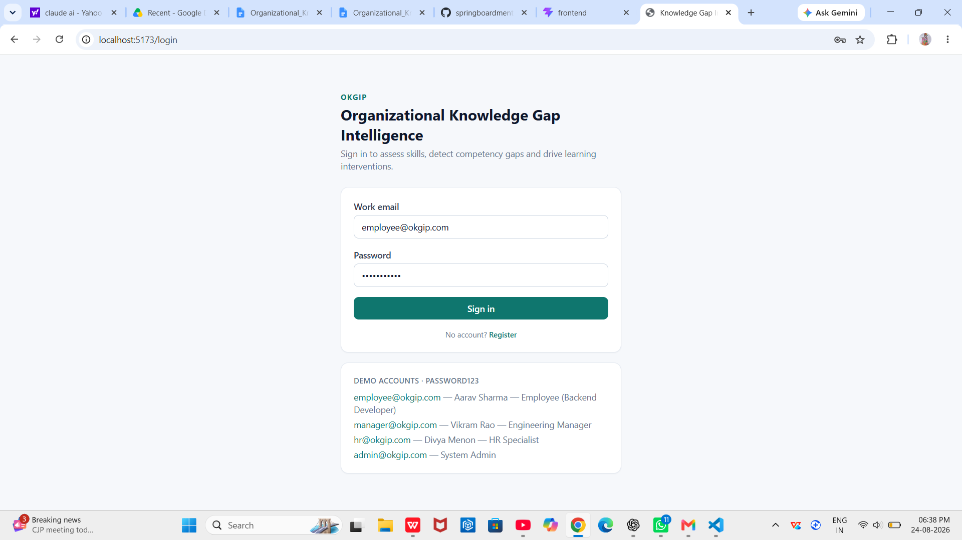
Implementation Status: Implemented

Role-Based Access Control — implementation depth
The Role enum defines six values (EMPLOYEE, MANAGER, HR, DEPARTMENT_HEAD, LD_ADMIN, ADMIN) and every issued JWT carries the user's role as a claim, and JwtAuthFilter grants a matching ROLE_<name> Spring Security authority. However, SecurityConfig.filterChain(...) only applies an explicit hasAnyRole(...) restriction to one route group — GET /api/competencies/**, which is restricted to HR, LD_ADMIN, ADMIN, DEPARTMENT_HEAD, MANAGER, EMPLOYEE (i.e., every defined role, which is functionally equivalent to "any authenticated user"). Every other authenticated route matches .anyRequest().authenticated() with no per-role restriction at the security-filter level. Where the code does restrict access by ownership (e.g., a user may only update or delete their own enrollment), that check is implemented manually inside the service layer (comparing e.getUser().getId() to the current user's id) rather than through Spring Security method security such as @PreAuthorize. This distinction is documented plainly here and revisited in Section 9.8 and Section 10.

5.2 Employee Profile & Skill Inventory

Purpose
Let an employee record and view their proficiency across the organization's skill catalog.

Functional Requirements
- List all catalog skills.
- List the current user's own skill inventory with level and source.
- Create or update a proficiency rating for a skill.

User Workflow
SkillProfile.jsx loads /api/skills and /api/me/skills in parallel, renders each skill with a level selector, and PUTs an update to /api/me/skills when the employee changes a rating.

Frontend Interaction
Two parallel GET calls via Promise.all in SkillProfile.jsx; a PUT call on save.

Backend Implementation
ProfileController reads/writes directly through SkillRepository and EmployeeSkillRepository (no dedicated SkillService class exists — this controller performs simple CRUD calls directly against repositories, unlike the other domain areas which route through a service class).

REST APIs
Method | Endpoint | Auth Required
GET | /api/skills | Yes
GET | /api/me/skills | Yes
PUT | /api/me/skills | Yes

Database Entities/Tables
skill, employee_skill (composite lookup by user_id + skill_id via findByUserIdAndSkillId).

Business Logic
Upsert semantics: if an EmployeeSkill row exists for (user, skill) it is updated in place; otherwise a new row is created. The source field defaults to "SELF" when the client does not supply one.

Validation
None beyond the existence check on the skill id (skills.findById(...).orElseThrow()); no bounds checking is applied to the level enum beyond normal JSON deserialization.

Error Handling
An unknown skillId throws NoSuchElementException from orElseThrow() with no explicit HTTP-status mapping, which Spring's default handling will surface as a generic HTTP 500 rather than a 404 — noted as an inconsistency relative to other modules in Section 9.8/10.
Implementation Status: Implemented

5.3 Competency Framework & Role Benchmarking

Purpose
Define the required proficiency per skill for each job role/department, forming the benchmark that the gap-analysis engine compares employees against.

Functional Requirements
- Store required proficiency level and a criticality flag per (job role, skill) pair.
- Expose the framework, optionally filtered by job role.

User Workflow
Competencies.jsx loads /api/competencies and renders the full framework as a reference table; there is no UI in the supplied frontend to create or edit competency rows — the framework is populated entirely by DataSeeder.java at startup.

Frontend Interaction
Single GET call, read-only rendering.

Backend Implementation
ProfileController.competencyFramework(jobRole) returns either the full RoleCompetencyRepository.findAll() list or a filtered findByJobRoleIgnoreCase(jobRole) list. The raw RoleCompetency JPA entity is returned directly as the response body rather than a DTO.

REST APIs
Method | Endpoint | Auth Required
GET | /api/competencies?jobRole= | Yes (any authenticated role)

Database Entities/Tables
role_competency (jobRole, department, skill_id, requiredLevel, critical).

Business Logic
"Benchmarking" in this codebase means the required-proficiency table itself; the comparison/scoring logic against an individual employee lives in GapAnalysisService (Section 5.4), not in this module.

Validation
None — this is a read-only endpoint in the supplied build.

Error Handling
Not applicable to a read-only, always-succeeding query.
[IN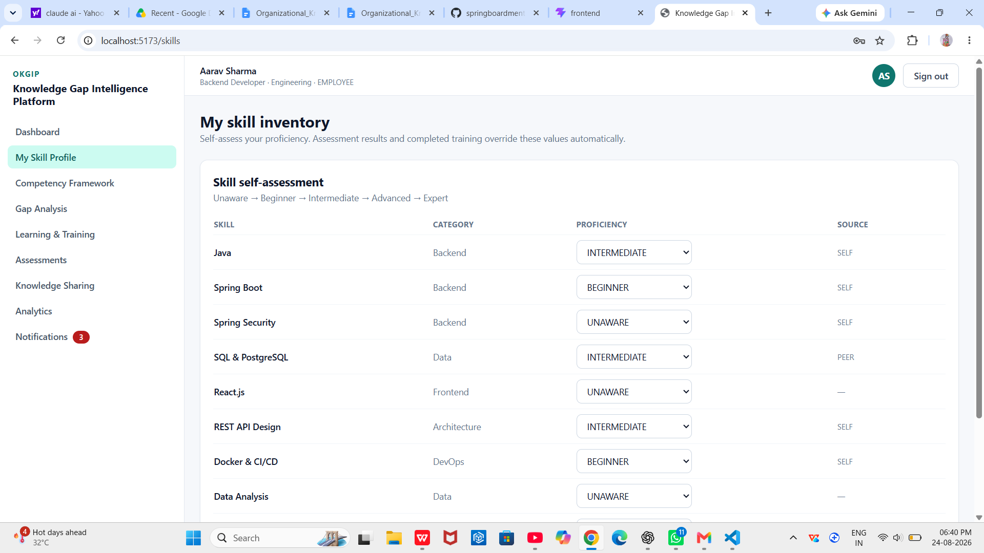
Implementation Status: Implemented (read-only framework; no authoring UI or endpoint)

5.4 Knowledge Gap Analysis

Purpose
Compute, per employee, the delta between required and current proficiency for every skill their role requires, with a severity classification, and roll this up into a readiness percentage; aggregate this across teams/departments into a heatmap.

Functional Requirements
- Individual gap summary for the current user or a specified employee id.
- Department/team gap heatmap.
- Severity scoring that weights both gap size and business criticality.

User Workflow
GapAnalysis.jsx requests /api/gaps/me and renders the ranked gap list plus a Heatmap.jsx visualization; Analytics.jsx separately requests manager/organization dashboards that embed the same heatmap data.

Frontend Interaction
GET /api/gaps/me on page load; the Heatmap component (components/Heatmap.jsx) renders HeatmapCell rows as a colored grid keyed by severityScore.

Backend Implementation
GapAnalysisService.forUser(User) — the required-competency list for the user's job role (falling back to their department if no job-role match exists) is compared against a map of the user's current EmployeeSkill levels (defaulting to UNAWARE where no rating exists).

REST APIs
Method | Endpoint | Auth Required
GET | /api/gaps/me | Yes
GET | /api/gaps/employee/{id} | Yes — no ownership/role check found; any authenticated user can request any employee id's summary (see Section 9.8/10)
GET | /api/gaps/heatmap?department= | Yes

Database Entities/Tables
Reads from role_competency and employee_skill; writes nothing (a pure read/compute operation).

Business Logic — verified gap and severity formula
As implemented in GapAnalysisService.forUser(...):
int gap = Math.max(0,
requiredLevel.getValue() - currentLevel.getValue());

int severityScore = gap * 25
+ (critical ? 20 : 0); // capped at 100

String severity =
gap == 0 ? "NONE"
: gap == 1 ? (critical ? "HIGH" : "LOW")
: gap == 2 ? (critical ? "CRITICAL" : "MEDIUM")
: "CRITICAL"; // gap >= 3

// a gap counts toward criticalGaps if:
// gap > 0 AND (critical OR gap >= 2)
Proficiency is a 5-level ordinal enum (UNAWARE=0, BEGINNER=1, INTERMEDIATE=2, ADVANCED=3, EXPERT=4). Readiness percent = round(100 × achievedTotal / requiredTotal), where achievedTotal sums min(currentLevel, requiredLevel) across all required skills and requiredTotal sums the required levels — i.e. over-achievement on one skill does not offset a deficit on another. Department and team heatmaps (heatmap(group, byDepartment)) average the per-skill gap across every member of the group and take the maximum severityScore observed for that (group, skill) pair as the cell's displayed severity.

Validation
None required — the computation is deterministic over existing data; an employee with no matching job-role or department competency rows simply receives an empty gap list and 100% readiness.

Error Handling
GapController.employee(id) calls gaps.forUserId(id), which calls users.findById(id).orElseThrow() — an unknown id surfaces as an unhandled NoSuchElementException (effectively HTTP 500), the same pattern noted in Section 5.2.
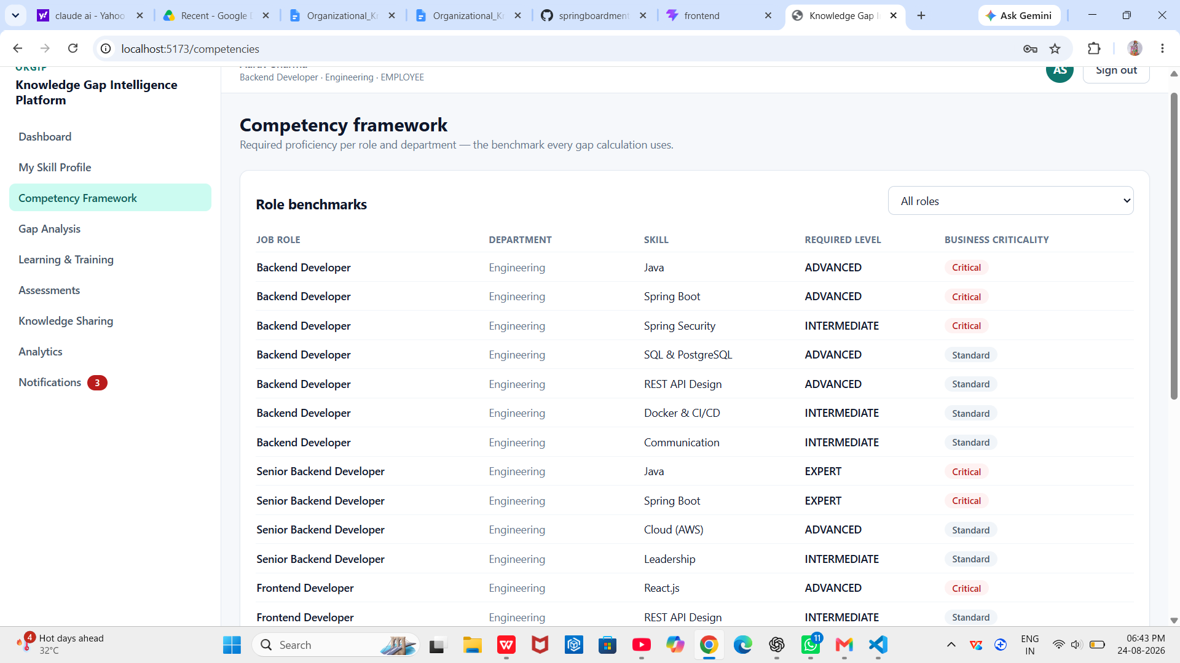
Implementation Status: Implemented

5.5 Training Recommendation

Purpose
Turn open skill gaps into a ranked list of specific training programs, and sequence the top recommendation per skill into a learning path.

Functional Requirements
- Score each catalog program against the user's current gaps.
- Return a sorted recommendation list with a human-readable reason.
- Generate an ordered, capped learning path.

User Workflow
Learning.jsx requests /api/recommendations/me and /api/recommendations/me/learning-path alongside the catalog and current enrollments, and lets the employee enroll directly from a recommendation card.

Frontend Interaction
Parallel GET requests on page load; a POST to enroll when the employee acts on a recommendation.

Backend Implementation
RecommendationService.forUser(User) iterates every TrainingProgram, skips any whose skill has no open gap for the user, and scores the rest.

REST APIs
Method | Endpoint | Auth Required
GET | /api/recommendations/me | Yes
GET | /api/recommendations/me/learning-path | Yes

Database Entities/Tables
Reads training_program, and (via GapAnalysisService) role_competency and employee_skill; also reads enrollment to flag whether the user is already enrolled in a given program.

Business Logic — verified scoring formula
int score = 40 + gap * 12 + (critical ? 20 : 0);
if (program.targetLevel >= gap.requiredLevel) score += 10;
if (program.targetLevel < gap.currentLevel) score -= 25;
if (program.internal) score += 5;
if (program.durationHours != null
&& program.durationHours <= 12) score += 5;
score = clamp(score, 5, 99);
Recommendations are sorted descending by this relevanceScore. A code comment in RecommendationService explicitly states the scoring function is "deliberately transparent so it can be swapped for an LLM-backed ranker (OpenAI) without changing the API contract" — this is documented design intent for a future extension, not an implemented AI feature; no such integration exists in the codebase (see Section 3.4).

Learning Path generation
learningPath(User) takes the sorted recommendation list, keeps only the single best-scoring program per distinct skill (LinkedHashMap.putIfAbsent), and returns up to 6 sequential LearningPathStep entries, each with an objective string such as "Reach ADVANCED proficiency in Spring Boot."

Validation
None beyond existing gap/catalog data integrity.

Error Handling
No explicit error paths — an empty gap list simply yields an empty recommendation/path list.

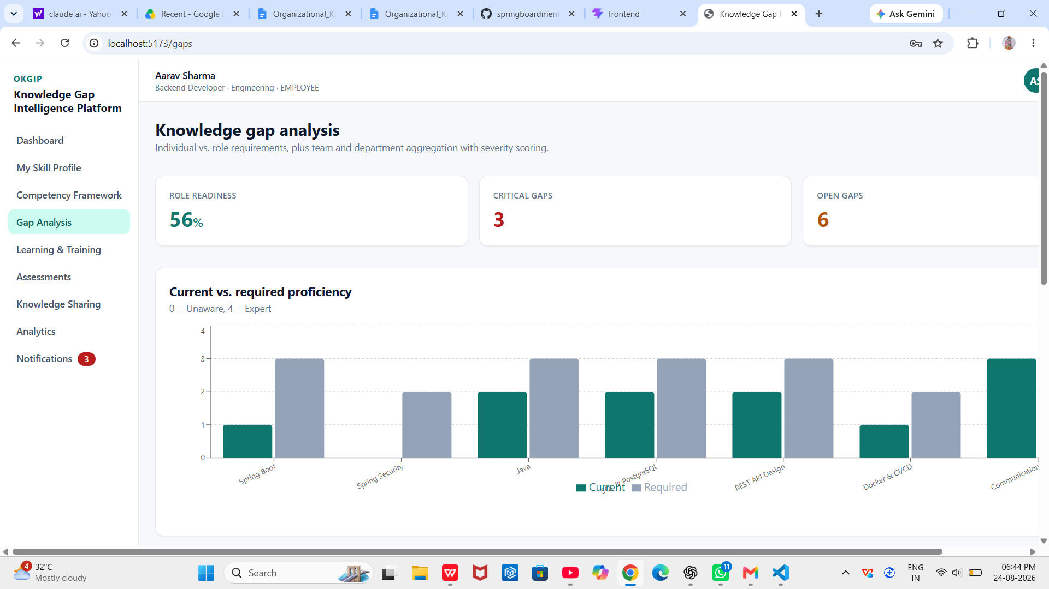
Implementation Status: Implemented (rule-based; AI/LLM ranking is a documented future extension point, not implemented)

5.6 Knowledge Sharing & Mentorship

Purpose
Match employees with open skill gaps to colleagues who are more proficient in that skill, and support lightweight knowledge sharing through scheduled sessions and articles.

Functional Requirements
- Suggest mentors ranked by match quality.
- Request and track a mentorship relationship's status.
- List and register for knowledge-sharing sessions.
- List knowledge articles.

User Workflow
Knowledge.jsx loads mentor suggestions, the user's mentorships, sessions, and articles in one Promise.all batch; the employee can request a mentor or register for a session from this page.

Frontend Interaction
Four parallel GET calls; POST calls for a mentorship request and for session registration.

Backend Implementation
MentorshipService.suggestions(User) iterates the mentee's open gaps and, for each, scans every EmployeeSkill row on that skill looking for a colleague whose level exceeds the mentee's current level and meets the required level.

REST APIs
Method | Endpoint | Auth Required
GET | /api/knowledge/mentors/suggestions | Yes
POST | /api/knowledge/mentorships | Yes
GET | /api/knowledge/mentorships/me | Yes
PATCH | /api/knowledge/mentorships/{id}?status= | Yes
GET | /api/knowledge/sessions | Yes
POST | /api/knowledge/sessions/{id}/register | Yes
GET | /api/knowledge/articles | Yes

Database Entities/Tables
mentorship_match, sharing_session, knowledge_article, plus reads of employee_skill and the gap-analysis result.

Business Logic — verified match-score formula
int score = 45
+ (mentorLevel.value - menteeCurrentLevel.value) * 12
+ (gapIsCritical ? 15 : 0)
+ (sameDepartment ? 8 : 0)
+ (mentorLevel == EXPERT ? 10 : 0);
score = min(score, 99);
Mentorship status is a free-text field ("REQUESTED", "ACTIVE", "COMPLETED" by convention in the seed data and the PATCH endpoint) rather than a Java enum — updateStatus(id, status) accepts any string with no validation against an allowed set. Session registration simply increments the registered counter on SharingSession with no capacity check against the seats field, so a session can be over-booked past its stated capacity.

Validation
No enum/whitelist validation on mentorship status; no seats-vs-registered capacity check on session registration (both noted above and revisited in Section 9.8).

Error Handling
Unknown mentor/session ids raise unhandled NoSuchElementException (orElseThrow() with no message or status mapping).
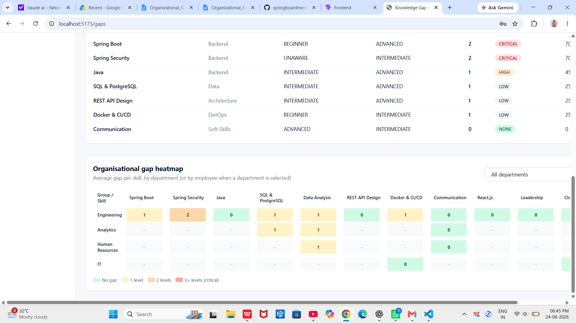
Implementation Status: Implemented

5.7 Learning Progress Tracking

Purpose
Let an employee enroll in a training program, update and complete it, and have their skill inventory automatically reflect that completion.

Functional Requirements
- Browse the training catalog.
- Enroll (idempotently — re-enrolling returns the existing enrollment rather than duplicating it).
- Update progress percent / status.
- Leave (delete) an enrollment.
- Apply a skill-level uplift on completion.

User Workflow
Learning.jsx (Enroll / progress +25% / mark complete / leave, per README) drives LearningController; a completed enrollment triggers a notification and a skill re-evaluation, both visible without a page reload where the frontend re-fetches state.

Frontend Interaction
GET catalog + enrollments on load; POST to enroll; PATCH to update progress (the frontend's "+25%" control PATCHes progressPercent incrementally); DELETE to unenroll.

Backend Implementation
LearningService.enroll(...) is idempotent per (user, program) via findByUserIdAndProgramId, and sets a 30-day due date on creation. updateProgress(...) clamps progressPercent to [0,100] and derives a status from percent when the client does not explicitly send one (>=100 → COMPLETED, >0 → IN_PROGRESS, else NOT_STARTED).

REST APIs
Method | Endpoint | Auth Required
GET | /api/learning/catalog | Yes
GET | /api/learning/enrollments | Yes
POST | /api/learning/programs/{programId}/enroll | Yes
PATCH | /api/learning/enrollments/{id}/progress | Yes (ownership-checked in service)
DELETE | /api/learning/enrollments/{id} | Yes (ownership-checked in service)

Database Entities/Tables
enrollment, training_program; writes to employee_skill on completion via applySkillUplift(...).

Business Logic — verified skill-uplift rule
// On first transition to COMPLETED / CERTIFIED:
int target = program.targetLevel.value;
int current = existingSkill?.level.value ?? 0;
if (target > current) {
// uplift by exactly one proficiency step,
// never further than the program's target level
newLevel = min(target, current + 1);
skill.level = newLevel;
skill.source = "TRAINING";
}
This is a single-step uplift, not a jump directly to the program's target level — completing one program moves the employee's recorded proficiency up by exactly one enum step (e.g. BEGINNER → INTERMEDIATE), capped at the program's target. Uplift only fires the first time completedAt is set (guarded by an if (e.getCompletedAt() == null) check), so re-saving an already-completed enrollment does not repeatedly uplift the skill. There is no "learning velocity" calculation in LearningService itself; a simple velocity number (completed-enrollment count × 10) is computed separately in DashboardController for the employee dashboard (Section 5.10).

Validation
progressPercent is clamped server-side to [0,100]; ownership of the enrollment is checked (403 Forbidden on mismatch).

Error Handling
Unknown program/enrollment id → 404 Not Found (ResponseStatusException); acting on another user's enrollment → 403 Forbidden.
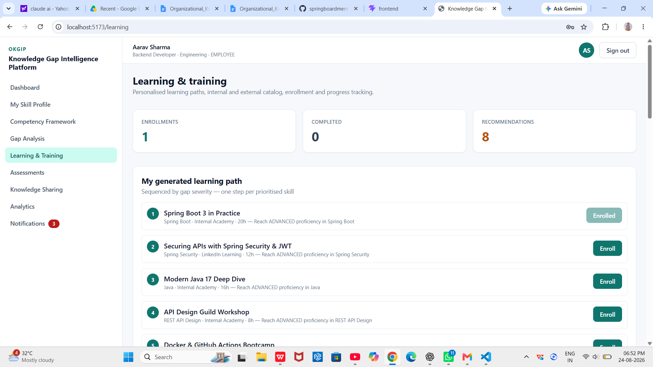
Implementation Status: Implemented

5.8 Assessment & Survey

Purpose
Deliver multiple-choice skill quizzes, grade them server-side, derive a proficiency level from the score, and feed that back into the employee's skill inventory.

Functional Requirements
- List available assessments and their question counts.
- Serve a quiz's questions without exposing correct answers.
- Accept and grade a submitted attempt.
- Show the employee's attempt history.

User Workflow
Assessments.jsx lists quizzes and past attempts, lets the employee start one (fetching its questions), submit answers, and immediately shows the graded result with per-question explanations.

Frontend Interaction
GET list + history on load; GET detail on quiz start; POST attempt on submit.

Backend Implementation
AssessmentController → AssessmentService. detail(id) returns QuestionView records that intentionally omit the correctOption field, so the answer key never reaches the client before submission — verified directly against the QuestionView record definition in Dtos.java, which excludes correctOption while AttemptResultView's GradedAnswer (returned only after submission) includes it.

REST APIs
Method | Endpoint | Auth Required
GET | /api/assessments | Yes
GET | /api/assessments/{id} | Yes
POST | /api/assessments/{id}/attempts | Yes
GET | /api/assessments/attempts/me | Yes

Database Entities/Tables
assessment, question, assessment_attempt; writes/updates employee_skill on submission.

Business Logic — verified grading and derivation rules
// per question: weight defaults to 1
total += question.weight;
if (selectedOption.equalsIgnoreCase(question.correctOption))
score += question.weight;

percent = round(100.0 * score / total);

Proficiency derive(percent):
percent >= 90 -> EXPERT
percent >= 75 -> ADVANCED
percent >= 55 -> INTERMEDIATE
percent >= 30 -> BEGINNER
else -> UNAWARE
After grading, the employee's EmployeeSkill row for the assessed skill is unconditionally set to the derived level (source = "ASSESSMENT"), which is then automatically reflected the next time gap analysis runs (GapAnalysisService reads live from employee_skill — there is no separate recalculation trigger to invoke; "automatic gap recalculation" in this codebase means the gap engine is stateless and always current, not that an explicit recompute step fires). A milestone notification is also pushed to the user summarizing the new proficiency.

Seeded assessment banks (verified in DataSeeder.java)
Assessment | Skill
Core Java Proficiency Quiz | Java
Spring Boot Fundamentals Quiz | Spring Boot
Spring Security & JWT Quiz | Spring Security
SQL & PostgreSQL Quiz | SQL & PostgreSQL
React.js Essentials Quiz | React.js
Professional Communication Assessment | Communication

Total seeded question bank: 45 multiple-choice questions across the six assessments above (counted directly from DataSeeder.java), matching the figure stated in README.md.

Validation
selectedOption is compared case-insensitively against correctOption; an unanswered question is simply marked incorrect (selected == null).

Error Handling
Unknown assessment id → 404 Not Found.
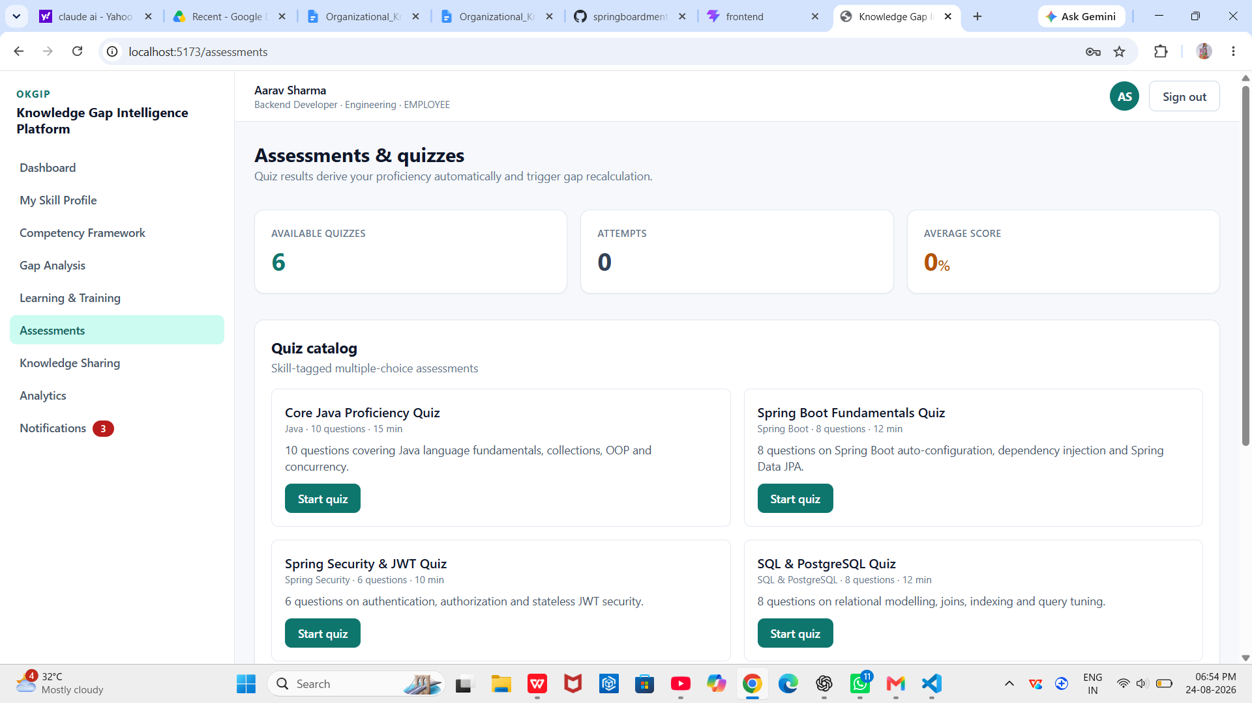
Implementation Status: Implemented

5.9 Notification Module

Purpose
Give each user a persistent, in-app record of significant events (milestones, mentorship activity) without requiring them to be online when the event occurred.

Functional Requirements
- List a user's notifications, newest first.
- Mark a single notification read.
- Mark all notifications read.

User Workflow
Notifications.jsx polls /api/notifications on load and lets the user clear the unread state in bulk.

Frontend Interaction
GET on load; PATCH read-all on user action. There is no per-item mark-read call wired into the visible Notifications.jsx page even though the backend exposes PATCH /{id}/read — noted as a partial frontend/backend pairing.

Backend Implementation
NotificationService.push(user, type, title, message) is called from LearningService, AssessmentService, and MentorshipService at the specific event points documented in Sections 5.6–5.8; NotificationController exposes list/read/read-all.

REST APIs
Method | Endpoint | Auth Required
GET | /api/notifications | Yes
PATCH | /api/notifications/{id}/read | Yes
PATCH | /api/notifications/read-all | Yes

Database Entities/Tables
notification (title, message, type as a free-text string, readFlag, createdAt).

Business Logic
Notification type is a free-text convention (GAP_ALERT, DEADLINE, RECOMMENDATION, MILESTONE, MENTORSHIP per the entity's code comment) rather than an enum; in the code paths actually exercised, only "MILESTONE" and "MENTORSHIP" types are ever pushed — GAP_ALERT, DEADLINE and RECOMMENDATION are declared conventions with no producing code found, so no gap-deadline or recommendation-triggered notification is actually generated.

Delivery channel
In-app only, via the REST API. No email (JavaMailSender), SMS (Twilio), or push (Firebase Cloud Messaging) delivery exists — see Section 3.4.

Validation
None.

Error Handling
markRead(id) silently no-ops on an unknown id (repo.findById(id).ifPresent(...)) rather than raising an error.

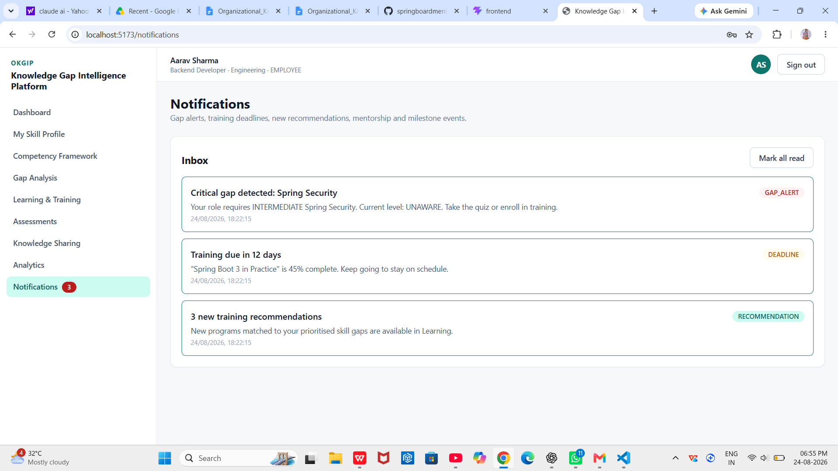
Implementation Status: Implemented (in-app only)

5.10 Analytics Dashboard

Purpose
Aggregate individual gap and training data into role-appropriate views: an employee's own snapshot, a manager's team view, and an organization-wide view.

Functional Requirements
- Employee dashboard: own gap summary, top recommendations, enrollments, attempt history, mentorships, a velocity figure.
- Manager dashboard: department readiness, critical-gap count, training adoption rate, heatmap, per-member snapshots.
- Organization dashboard: org-wide readiness, department breakdown, top skill gaps, training-provider effectiveness.
- 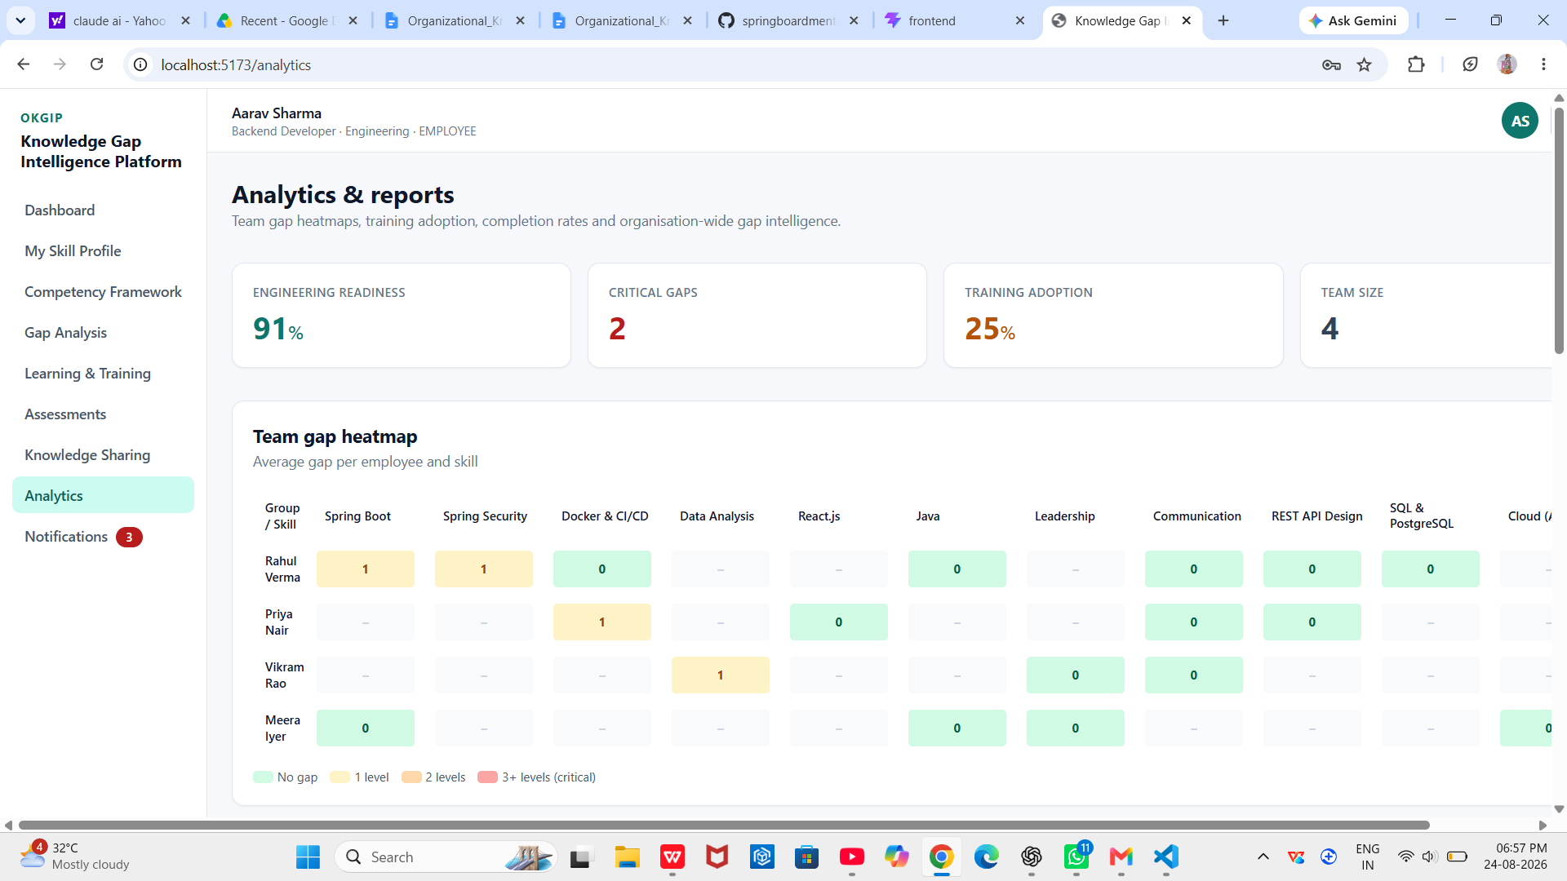

User Workflow
Dashboard.jsx (home page after login) loads /api/dashboard/employee. Analytics.jsx loads /api/dashboard/manager and renders a bar chart of top skill gaps and a pie chart (verified Recharts components: BarChart, PieChart).

Frontend Interaction
Single GET per dashboard endpoint; charts rendered client-side from the returned aggregate JSON.

Backend Implementation
DashboardController composes EmployeeDashboard from five services in one request (gaps, recommendations, learning, assessments, mentorship) plus a locally computed velocity value. AnalyticsService.manager(...) and .organization(...) do the heavier aggregation.

REST APIs
Method | Endpoint | Auth Required
GET | /api/dashboard/employee | Yes
GET | /api/dashboard/manager | Yes — no check that the caller actually holds the MANAGER role or manages the returned department; the endpoint uses the caller's own department field regardless of role (see Section 9.8/10)
GET | /api/dashboard/organization | Yes — same observation: no role gate found

Business Logic — verified derived metrics
- learningVelocity (employee dashboard) = count(enrollments with a non-null completedAt) × 10 — a simple proxy metric, not a time-normalized rate.
- Manager dashboard readiness = average of each team member's individual readinessPercent; trainingAdoptionPercent = percentage of team members with at least one enrollment.
- Organization dashboard readiness = average of each department's average readiness; completionRate = percentage of all enrollments in status COMPLETED or CERTIFIED; avgSkillImprovement = average percent score across all assessment attempts (a proxy for organization-wide assessment performance, not a true before/after improvement measurement).
- Top skill gaps = skills with average gap > 0 across the organization, sorted descending by average gap, with an affected-employee count.
- Training effectiveness = per-provider enrollment count, completion count, and completion rate.

Validation
None — purely computed/read data.

Error Handling
No explicit error branches; empty teams/departments are guarded against division by zero in the aggregate calculations (ternary checks for isEmpty()).

5.11 Reports & Export

Purpose
As specified in the module list, this module would allow exporting gap, training, or analytics data as PDF or Excel reports.

Functional Requirements
Not applicable — no functional requirements for this module are met by the supplied source.

User Workflow / Frontend Interaction / Backend Implementation
Not Verified in the provided source code. No PDF library (e.g., iText, OpenPDF), no spreadsheet library (e.g., Apache POI), and no export-oriented controller endpoint or frontend "download/export" control were found anywhere in the backend or frontend source.

REST APIs
None exist.

Database Entities/Tables
Not applicable.

Business Logic / Validation / Error Handling
Not applicable — no implementation exists to describe.

Screenshot Placeholder
Not applicable — no export UI exists to capture.
Implementation Status: Not Verified in the provided source code

5.12 Final Integration, Testing & Deployment

Purpose
Bring the frontend and backend together into a working, verifiable, deployable system.

Integration — implemented
The Vite dev server proxies /api/** to the backend at http://localhost:8081 (vite.config.js), and the frontend's Axios base URL is configurable via VITE_API_BASE_URL (.env.example). CORS is explicitly configured on the backend (SecurityConfig.corsConfigurationSource()) to allow http://localhost:5173 and http://localhost:3000 with credentials, which is consistent with running the two applications as separate processes during development, as the README instructs.

Testing
Not Verified in the provided source code. spring-boot-starter-test and spring-security-test are declared in pom.xml with test scope, and React's tooling (Vite/ESLint per the README's recommended extensions) would support adding React Testing Library, but no test source directory (backend/src/test or a frontend test folder), no test class, and no test script beyond dev/build/preview in package.json exist in the supplied archive. No CI configuration (e.g., a .github/workflows directory, GitLab CI file, or Jenkinsfile) was found either.

Deployment
Covered in Section 4.6: only the PostgreSQL database tier has a deployment artifact (docker-compose.yml). The application tiers are run directly via Maven and the Vite dev server, with no build-and-deploy pipeline in the archive.

REST APIs / Database Entities/Tables
Not applicable to this module directly — it concerns process, not a feature surface.
Not applicable — no test runner or CI dashboard output exists to capture.

BACKEND DEVELOPMENT – INDIVIDUAL CONTRIBUTION
This section documents my individual contribution to the project — the Spring Boot backend — in greater technical depth, as instructed. All claims below are verified directly against the backend/src/main/java/com/okgip source tree.

6.1 Individual Role
My responsibility on the team was backend development: the REST API surface, the domain services implementing the platform's core algorithms (gap analysis, recommendation scoring, mentor matching, assessment grading, analytics aggregation), the JPA persistence model, JWT-based security, and the demonstration data seeder that gives the frontend a realistic dataset to build against. The React frontend consumes this API surface as a client and is documented in this report for completeness, but was not my individual contribution.

6.2 Backend Architecture
The backend is a single-module, layered Spring Boot 3.3.4 monolith (see Section 4.2 for the full diagram): a stateless REST controller layer, a service layer holding all domain logic, a Spring Data JPA repository layer, and a JPA entity/model layer, with cross-cutting security and configuration held in a separate config package and startup seeding in a bootstrap package. There is no separate business-facade or CQRS split — each controller method maps directly to one service call.

6.3 Package Structure
Package (actual) | Contents (verified)
com.okgip | OkgipApplication — the @SpringBootApplication entry point.
com.okgip.config | SecurityConfig, JwtService, JwtAuthFilter, CurrentUser.
com.okgip.model | 13 @Entity classes + 4 enums (Role, Proficiency, AssessmentType, TrainingStatus).
com.okgip.repo | 13 Spring Data JPA repository interfaces.
com.okgip.service | 8 @Service classes — AuthService, GapAnalysisService, RecommendationService, LearningService, AssessmentService, MentorshipService, NotificationService, AnalyticsService.
com.okgip.web | 9 @RestController classes.
com.okgip.dto | One Dtos.java holding ~30 Java records used as request/response payloads.
com.okgip.bootstrap | DataSeeder — a CommandLineRunner that seeds demo data on first boot only (guarded by users.count() > 0).

This exactly matches the requirement template's example package list (config, model, repo, service, web, dto, bootstrap) — no additional or renamed top-level packages were introduced.

6.4 Controller Layer
Controller | Endpoint | HTTP Method | Purpose
AuthController | POST /api/auth/login | POST | Authenticate and issue a JWT
AuthController | POST /api/auth/register | POST | Create a new user and issue a JWT
AuthController | GET /api/auth/me | GET | Return the authenticated user's profile
ProfileController | GET /api/skills | GET | List the skill catalog
ProfileController | GET /api/me/skills | GET | List the current user's skill inventory
ProfileController | PUT /api/me/skills | PUT | Create/update a proficiency rating
ProfileController | GET /api/competencies | GET | List the role competency framework
ProfileController | GET /api/employees | GET | List all employees
GapController | GET /api/gaps/me | GET | Current user's gap summary
GapController | GET /api/gaps/employee/{id} | GET | A specific employee's gap summary
GapController | GET /api/gaps/heatmap | GET | Department or team gap heatmap
RecommendationController | GET /api/recommendations/me | GET | Ranked training recommendations
RecommendationController | GET /api/recommendations/me/learning-path | GET | Generated learning path
LearningController | GET /api/learning/catalog | GET | Full training catalog
LearningController | GET /api/learning/enrollments | GET | Current user's enrollments
LearningController | POST /api/learning/programs/{programId}/enroll | POST | Enroll in a program
LearningController | PATCH /api/learning/enrollments/{id}/progress | PATCH | Update progress/status
LearningController | DELETE /api/learning/enrollments/{id} | DELETE | Unenroll
AssessmentController | GET /api/assessments | GET | List assessments
AssessmentController | GET /api/assessments/{id} | GET | Assessment detail with questions
AssessmentController | POST /api/assessments/{id}/attempts | POST | Submit and grade an attempt
AssessmentController | GET /api/assessments/attempts/me | GET | Attempt history
KnowledgeController | GET /api/knowledge/mentors/suggestions | GET | Ranked mentor suggestions
KnowledgeController | POST /api/knowledge/mentorships | POST | Request a mentorship
KnowledgeController | GET /api/knowledge/mentorships/me | GET | Own mentorships (as mentor or mentee)
KnowledgeController | PATCH /api/knowledge/mentorships/{id} | PATCH | Update mentorship status
KnowledgeController | GET /api/knowledge/sessions | GET | List sharing sessions
KnowledgeController | POST /api/knowledge/sessions/{id}/register | POST | Register for a session
KnowledgeController | GET /api/knowledge/articles | GET | List knowledge articles
NotificationController | GET /api/notifications | GET | List notifications
NotificationController | PATCH /api/notifications/{id}/read | PATCH | Mark one notification read
NotificationController | PATCH /api/notifications/read-all | PATCH | Mark all notifications read
DashboardController | GET /api/dashboard/employee | GET | Composite employee dashboard
DashboardController | GET /api/dashboard/manager | GET | Manager/team dashboard
DashboardController | GET /api/dashboard/organization | GET | Organization-wide dashboard

Total: 9 controllers, 35 endpoints, all under /api/**. Every controller resolves the acting user through the shared CurrentUser component rather than a Spring-injected Principal/Authentication parameter.

6.5 Service Layer
Service | Business logic (verified)
AuthService | Login/registration, password verification, JWT issuance with role/name claims.
GapAnalysisService | Core gap computation, severity scoring, readiness percent, department/team heatmap aggregation (Section 5.4).
RecommendationService | Rule-based training-program scoring and learning-path generation (Section 5.5).
LearningService | Enrollment lifecycle, progress tracking, completion, single-step skill uplift (Section 5.7).
AssessmentService | Quiz delivery (answer-key withheld), grading, proficiency derivation, attempt history (Section 5.8).
MentorshipService | Mentor-match scoring, mentorship request/status workflow, sessions, articles (Section 5.6).
NotificationService | Persist and query in-app notifications; push(...) is called from three other services at specific event points.
AnalyticsService | Manager and organization dashboard aggregation: readiness averages, heatmaps, top skill gaps, training-provider effectiveness (Section 5.10).

Every service is a plain Spring @Service with constructor injection (no field injection anywhere in the codebase) and no @Transactional annotations were found — multi-step writes (e.g., enrollment completion, which both updates the enrollment and writes an employee_skill row) run without an explicit transaction boundary beyond Hibernate's own session-per-repository-call default, which is noted here rather than assumed to be transactionally safe across the two writes.

6.6 Repository Layer
Repository | Custom query methods (verified)
UserRepository | findByEmail, existsByEmail, findByDepartment
SkillRepository | findByName
EmployeeSkillRepository | findByUserId, findByUserIdAndSkillId, findBySkillId
RoleCompetencyRepository | findByJobRoleIgnoreCase, findByDepartmentIgnoreCase
AssessmentRepository | Standard CRUD only (JpaRepository<Assessment, Long>)
QuestionRepository | findByAssessmentId
AssessmentAttemptRepository | findByUserIdOrderBySubmittedAtDesc
TrainingProgramRepository | findBySkillId, findBySkillIdIn
EnrollmentRepository | findByUserId, findByUserIdAndProgramId, existsByUserIdAndProgramId
MentorshipMatchRepository | findByMenteeId, findByMentorId
SharingSessionRepository | Standard CRUD only
KnowledgeArticleRepository | Standard CRUD only
NotificationRepository | findByUserIdOrderByCreatedAtDesc

All 13 repositories extend Spring Data JPA's JpaRepository<T, Long> and rely entirely on Spring Data's derived query-method naming convention (e.g., findByUserIdAndSkillId) — no @Query-annotated JPQL/native queries were found anywhere in the repository layer, and no Querydsl or Criteria API usage exists.

6.7 Entity/Model Layer
Section 4.3 gives the full entity-relationship detail. All 13 entities use Lombok (@Getter @Setter @NoArgsConstructor @AllArgsConstructor @Builder) to eliminate boilerplate, an IDENTITY-strategy generated Long id, and Java enums mapped with @Enumerated(EnumType.STRING) for Role, Proficiency, AssessmentType, and TrainingStatus so that stored values remain human-readable in the database rather than ordinal integers.

6.8 DTO Layer
Rather than one class per DTO, the project consolidates every request/response payload as a nested Java record inside a single Dtos.java class (com.okgip.dto.Dtos). This includes plain request bodies (LoginRequest, RegisterRequest, SkillUpsertRequest, ProgressUpdateRequest, SubmitAttemptRequest, MentorshipRequestBody) and response views (UserView, GapSummary, GapItem, HeatmapCell, RecommendationView, LearningPathStep, EnrollmentView, AssessmentView/DetailView, QuestionView, AttemptResultView/HistoryView, MentorSuggestion, MentorshipView, SessionView, ArticleView, NotificationView, EmployeeDashboard, ManagerDashboard, OrgDashboard, and others). Several response endpoints (GET /api/competencies, GET /api/learning/catalog) return the raw JPA entity directly rather than a mapped view record — noted as an inconsistency in Section 9.8.

6.9 Security Implementation
Verified configuration in SecurityConfig.java, JwtService.java, and JwtAuthFilter.java:
- CSRF is disabled (appropriate for a stateless, token-authenticated JSON API with no browser form posts).
- Session creation policy is STATELESS — no server-side session is created or consulted.
- CORS is explicitly configured from the app.cors.allowed-origins property, restricted to the two local development origins, with credentials allowed.
- /api/auth/**, /h2-console/**, and /actuator/** are permitted without authentication; GET /api/meta/** is permitted (though no controller currently maps to /api/meta/**, so this rule is presently inert).
- Every other request requires authentication (anyRequest().authenticated()).
- JwtAuthFilter runs once per request ahead of UsernamePasswordAuthenticationFilter, reads the Bearer token, validates its signature and expiry via JwtService, loads the matching User, and populates the SecurityContext with that User as the principal and a single ROLE_<name> authority.
- Passwords are hashed with BCryptPasswordEncoder (registered as the PasswordEncoder bean) and never stored or compared in plaintext.
- JWTs are signed with HMAC-SHA256 using a secret from app.jwt.secret (application.yml ships a placeholder value with an explicit "change-me-in-production" comment) and expire after app.jwt.expiration-ms (24 hours, 86,400,000 ms, in the supplied configuration).

Verified JWT issuance snippet (JwtService.generateToken)
public String generateToken(String email, Map<String,Object> claims) {
Date now = new Date();
return Jwts.builder()
.setClaims(claims)
.setSubject(email)
.setIssuedAt(now)
.setExpiration(new Date(now.getTime() + expirationMs))
.signWith(key, SignatureAlgorithm.HS256)
.compact();
}

6.10 Database Integration
Spring Data JPA over Hibernate, with ddl-auto: update (schema is generated/altered automatically from the entity model — there are no committed migration scripts). The default profile targets an in-memory H2 database running in PostgreSQL compatibility mode (MODE=PostgreSQL), which lets the same JPQL/derived queries behave consistently whether the active profile is the default (H2) or postgres (a real PostgreSQL 16 instance, provisioned by docker-compose.yml). open-in-view is explicitly set to false, meaning the Hibernate session is closed before the view/serialization layer renders the response — DTOs must be fully populated inside the service/transaction boundary, which is consistent with the DTO-record pattern used throughout.

6.11 Business Logic
The four scoring/derivation algorithms that are the core intellectual content of the backend are documented in full, with the exact verified formulas, in Sections 5.4 (gap severity), 5.5 (recommendation relevance), 5.6 (mentor match score), and 5.8 (assessment grading and proficiency derivation). All four are implemented as plain, deterministic Java arithmetic inside the relevant service class — none call an external scoring or ML service.

6.12 API Integration
The React frontend communicates exclusively through a single configured Axios instance (src/api/client.js). A request interceptor reads the JWT from localStorage (key kgip_token) and attaches it as an Authorization: Bearer header on every outgoing call; a response interceptor watches for HTTP 401 responses and, outside the login page, clears the stored token/user and redirects to /login — a simple client-side session-expiry handler. In local development, Vite's dev-server proxy (vite.config.js) forwards /api requests to http://localhost:8081, avoiding the need for CORS during that specific dev-server-to-backend hop, while the backend's own CORS configuration additionally allows direct cross-origin calls to port 8081 from the Vite dev origins.

6.13 Error Handling & Validation
There is no @ControllerAdvice / global exception handler in the codebase. Error responses are produced by services throwing org.springframework.web.server.ResponseStatusException directly with a specific HttpStatus and message (401 for bad credentials, 409 for duplicate registration, 403 for acting on another user's enrollment, 404 for a missing program/assessment/enrollment). A smaller number of lookups instead call Optional.orElseThrow() with no argument (e.g., in ProfileController.upsertSkill, GapAnalysisService.forUserId, MentorshipService.request/updateStatus), which throws a plain NoSuchElementException that Spring's default error handling will return as an HTTP 500 rather than a more appropriate 404 — this inconsistency is verified directly in the source and is not evenly applied across all modules. Request-body validation (jakarta.validation / @Valid) is not used anywhere despite spring-boot-starter-validation being a declared dependency.

6.14 Individual Contribution Summary
Task | Backend Contribution | Status
REST API design & implementation | 9 controllers, 35 endpoints, all backend work | Complete
Domain/business logic | 8 services incl. gap analysis, recommendation, matching, grading, analytics algorithms | Complete
Persistence layer | 13 JPA entities, 13 Spring Data repositories, H2/PostgreSQL dual-profile config | Complete
Security | JWT issuance/validation, Spring Security filter chain, BCrypt, CORS | Complete
Demo data | DataSeeder — 8 users, 11 skills, 24 competency rows, 13 programs, 6 assessments/45 questions, sessions & articles | Complete
Automated testing | No test classes present in the supplied source | Not Verified in the provided source code
CI/CD & containerized app deployment | No pipeline or application Dockerfiles present | Not Verified in the provided source code

API DOCUMENTATION
All 35 endpoints below are verified directly against the @RestController classes in com.okgip.web and the record definitions in com.okgip.dto.Dtos. Authentication uses the header Authorization: Bearer <token> obtained from /api/auth/login or /api/auth/register. Full request and response detail is given for the endpoints central to each milestone; the complete endpoint index follows in the summary table.

7.1 Authentication Endpoints

POST /api/auth/login
Authentication Required: No. Purpose: exchange credentials for a JWT.
Request:
{
"email": "employee@okgip.com",
"password": "password123"
}
Response (200):
{
"token": "<JWT>",
"user": {
"id": 1, "email": "employee@okgip.com",
"fullName": "Aarav Sharma", "role": "EMPLOYEE",
"department": "Engineering", "jobRole": "Backend Developer",
"avatarInitials": "AS"
}
}
Status Codes: 200 OK · 401 Unauthorized (invalid credentials).

POST /api/auth/register
Authentication Required: No. Purpose: create an account and receive a JWT.
Request:
{
"email": "new.hire@okgip.com", "password": "password123",
"fullName": "New Hire", "department": "Engineering",
"jobRole": "Backend Developer", "role": null
}
Response: same AuthResponse shape as login. Status Codes: 200 OK · 409 Conflict (email already registered).

GET /api/auth/me
Authentication Required: Yes. Response: the UserView shown above. Status Codes: 200 OK · 401 Unauthorized.

7.2 Gap Analysis Endpoints

GET /api/gaps/me
Authentication Required: Yes. Purpose: return the current user's full gap summary.
Response (200) — abbreviated:
{
"userId": 1, "fullName": "Aarav Sharma",
"jobRole": "Backend Developer", "department": "Engineering",
"readinessPercent": 61, "criticalGaps": 2, "totalGaps": 4,
"gaps": [
{ "skillId": 3, "skillName": "Spring Security",
"category": "Backend", "currentLevel": "UNAWARE",
"requiredLevel": "INTERMEDIATE", "gap": 2,
"critical": true, "severity": "CRITICAL",
"severityScore": 70 }
]
}
Status Codes: 200 OK · 401 Unauthorized.

GET /api/gaps/heatmap?department=
Authentication Required: Yes. Purpose: aggregated gap heatmap, by department (no query param) or by team member (department supplied).
Response (200) — abbreviated array of HeatmapCell:
[
{ "group": "Engineering", "skillName": "Spring Security",
"averageGap": 1, "severityScore": 70 }
]

7.3 Recommendation & Learning Endpoints

GET /api/recommendations/me
Authentication Required: Yes. Response (200) — abbreviated:
[
{ "programId": 5, "title": "Securing APIs with Spring Security & JWT",
"provider": "LinkedIn Learning", "skillName": "Spring Security",
"targetLevel": "ADVANCED", "durationHours": 12,
"internal": false, "relevanceScore": 84,
"reason": "Closes a critical-level gap in Spring Security (UNAWARE -> INTERMEDIATE required) on a business-critical competency.",
"enrolled": false }
]

POST /api/learning/programs/{programId}/enroll
Authentication Required: Yes. Request body: none. Response (200):
{
"id": 12, "programId": 5, "programTitle": "Securing APIs with Spring Security & JWT",
"provider": "LinkedIn Learning", "skillName": "Spring Security",
"status": "NOT_STARTED", "progressPercent": 0,
"enrolledAt": "2026-08-01T10:15:00", "completedAt": null,
"dueAt": "2026-08-31T10:15:00"
}
Status Codes: 200 OK (idempotent — re-enrolling returns the existing row) · 404 Not Found (unknown program).

PATCH /api/learning/enrollments/{id}/progress
Request:
{
"progressPercent": 100,
"status": "COMPLETED"
}
Status Codes: 200 OK · 403 Forbidden (not the caller's enrollment) · 404 Not Found.

7.4 Assessment Endpoints

POST /api/assessments/{id}/attempts
Authentication Required: Yes. Request:
{
"answers": [
{ "questionId": 101, "selectedOption": "B" },
{ "questionId": 102, "selectedOption": "A" }
]
}
Response (200) — abbreviated:
{
"attemptId": 44, "assessmentTitle": "Spring Security & JWT Quiz",
"skillName": "Spring Security", "score": 7, "total": 8, "percent": 88,
"derivedLevel": "ADVANCED",
"message": "Strong result — this skill is no longer a priority gap.",
"answers": [ { "questionId": 101, "selectedOption": "B",
"correctOption": "B", "correct": true,
"explanation": "..." } ]
}
Status Codes: 200 OK · 404 Not Found (unknown assessment).

7.5 Knowledge & Notification Endpoints

POST /api/knowledge/mentorships
Request:
{
"mentorId": 4,
"skillId": 3
}
Response (200) — a MentorshipView with id, mentorName, menteeName, skillName, matchScore, status ("REQUESTED"), createdAt. Status Codes: 200 OK.

GET /api/notifications
Response (200) — abbreviated array of NotificationView: id, title, message, type, read, createdAt.

7.6 Dashboard Endpoints
GET /api/dashboard/employee, /api/dashboard/manager, and /api/dashboard/organization return the composite EmployeeDashboard, ManagerDashboard, and OrgDashboard records respectively, whose exact fields are given in Sections 5.10 and 6.8. These are read-only, parameter-free GET requests.

7.7 Complete Endpoint Index
Method | Endpoint | Auth Required
POST | /api/auth/login | No
POST | /api/auth/register | No
GET | /api/auth/me | Yes
GET | /api/skills | Yes
GET | /api/me/skills | Yes
PUT | /api/me/skills | Yes
GET | /api/competencies | Yes
GET | /api/employees | Yes
GET | /api/gaps/me | Yes
GET | /api/gaps/employee/{id} | Yes
GET | /api/gaps/heatmap | Yes
GET | /api/recommendations/me | Yes
GET | /api/recommendations/me/learning-path | Yes
GET | /api/learning/catalog | Yes
GET | /api/learning/enrollments | Yes
POST | /api/learning/programs/{programId}/enroll | Yes
PATCH | /api/learning/enrollments/{id}/progress | Yes
DELETE | /api/learning/enrollments/{id} | Yes
GET | /api/assessments | Yes
GET | /api/assessments/{id} | Yes
POST | /api/assessments/{id}/attempts | Yes
GET | /api/assessments/attempts/me | Yes
GET | /api/knowledge/mentors/suggestions | Yes
POST | /api/knowledge/mentorships | Yes
GET | /api/knowledge/mentorships/me | Yes
PATCH | /api/knowledge/mentorships/{id} | Yes
GET | /api/knowledge/sessions | Yes
POST | /api/knowledge/sessions/{id}/register | Yes
GET | /api/knowledge/articles | Yes
GET | /api/notifications | Yes
PATCH | /api/notifications/{id}/read | Yes
PATCH | /api/notifications/read-all | Yes
GET | /api/dashboard/employee | Yes
GET | /api/dashboard/manager | Yes
GET | /api/dashboard/organization | Yes

DATABASE DESIGN

8.1 Database Overview
The platform uses a single relational schema generated by Hibernate from 13 @Entity classes (ddl-auto: update — no committed SQL DDL or migration tool exists in the archive). Two Spring profiles target two different engines against the identical entity model: the default profile runs an in-memory H2 database in PostgreSQL compatibility mode, and the postgres profile targets a real PostgreSQL 16 instance (provisioned by docker-compose.yml for local use). Both profiles use identical entity mappings, so the schema is portable between the two by design.

8.2 Entity Descriptions
Entity | Description (verified)
User | An account: credentials, role, department, job role. Root of ownership for skills, enrollments, attempts, notifications, and mentorships.
Skill | A named competency in the catalog (e.g., "Java", "React.js"), with a category and description.
EmployeeSkill | One user's proficiency rating on one skill, with a source tag (SELF/PEER/MANAGER/ASSESSMENT/TRAINING).
RoleCompetency | One required-proficiency row for a (job role, skill) pair, with a criticality flag.
Assessment | A quiz definition tied to one skill, with a type and a time limit.
Question | One multiple-choice question belonging to an assessment, with four options and the correct one.
AssessmentAttempt | One graded submission by a user for an assessment, including the derived proficiency.
TrainingProgram | A catalog training offering (internal or external), tied to a target skill and target proficiency.
Enrollment | A user's enrollment in a training program: status, progress, timestamps.
MentorshipMatch | A mentor–mentee–skill relationship with a match score and status.
SharingSession | A scheduled knowledge-sharing session hosted on a skill, with a seat count and a registration count.
KnowledgeArticle | A written article tied to an author and a skill.
Notification | One in-app notification for a user.

8.3 Relationships
All relationships in the model are unidirectional @ManyToOne mappings from the child entity toward its parent(s); Section 4.3 lists the complete set. No bidirectional (@OneToMany-mapped) collections, and no many-to-many relationships, exist anywhere in the entity model — every cross-entity list (an employee's skills, a program's enrollments, etc.) is obtained by calling a repository's findByXxx method rather than by navigating a JPA-managed collection.

8.4 Primary and Foreign Keys
Every entity uses a single surrogate Long id primary key with GenerationType.IDENTITY. Foreign keys are declared implicitly through @ManyToOne(optional = false/true) associations — Hibernate names the physical foreign-key columns automatically (e.g., user_id, skill_id, assessment_id) since no explicit @JoinColumn name overrides were found. Skill.name and User.email each carry a unique database constraint (@Column(unique = true)); no other uniqueness constraints exist (for example, nothing prevents seeding two identical RoleCompetency rows for the same job role/skill pair, though the seeder does not do this).

8.5 JPA/Hibernate Mapping
- Enums (Role, Proficiency, AssessmentType, TrainingStatus) are persisted with @Enumerated(EnumType.STRING), so the database stores readable names rather than ordinal integers — a deliberate, verified choice that also protects existing data if enum ordering changes.
- Long text fields carry an explicit @Column(length = …) (e.g., Assessment.description at 1000, KnowledgeArticle.content at 4000, Notification.message at 1000).
- All entities use Lombok's @Builder alongside @NoArgsConstructor/@AllArgsConstructor, giving a fluent construction API without hand-written builders.
- open-in-view is disabled (spring.jpa.open-in-view: false), so all lazy associations must be resolved inside the service layer before the DTO record is built — consistent with how every service in this codebase eagerly maps entities to DTO records before returning.

8.6 Important Queries
All custom queries in the codebase are Spring Data derived query methods (no @Query-annotated JPQL/native SQL exists anywhere). The most structurally significant ones:
List<RoleCompetency> findByJobRoleIgnoreCase(String jobRole);
List<RoleCompetency> findByDepartmentIgnoreCase(String department);
// drives GapAnalysisService's required-competency lookup,
// with a job-role match tried first and a department
// fallback if no job-role rows exist

Optional<EmployeeSkill> findByUserIdAndSkillId(Long userId, Long skillId);
// the upsert key for an employee's proficiency rating

boolean existsByUserIdAndProgramId(Long userId, Long programId);
// backs the 'enrolled' flag surfaced on each recommendation

List<AssessmentAttempt> findByUserIdOrderBySubmittedAtDesc(Long userId);
List<NotificationRepository> findByUserIdOrderByCreatedAtDesc(Long userId);
// both provide reverse-chronological history without an
// explicit @Query — Spring Data parses the method name

8.7 Database Configuration
Verified from application.yml (default profile):
spring.datasource.url:
jdbc:h2:mem:kgip;DB_CLOSE_DELAY=-1;MODE=PostgreSQL
spring.datasource.driver-class-name: org.h2.Driver
spring.h2.console.enabled: true (path: /h2-console)
spring.jpa.hibernate.ddl-auto: update
spring.jpa.open-in-view: false
Verified postgres profile (activated with --spring.profiles.active=postgres):
spring.datasource.url:
jdbc:postgresql://localhost:5432/kgip
spring.datasource.username: postgres
spring.datasource.password: postgres
spring.datasource.driver-class-name: org.postgresql.Driver
The credentials above are development defaults shipped in application.yml and docker-compose.yml, not production secrets; the JWT secret similarly carries an explicit "change-me-in-production" placeholder comment in the same file.

TESTING, VALIDATION & CODE QUALITY

9.1 Testing Strategy
Not Verified in the provided source code. No test plan, test strategy document, or test source directory exists in the archive.

9.2 Unit Testing
Not Verified in the provided source code. No JUnit test classes exist under backend/src/test (indeed, no backend/src/test directory exists at all), despite spring-boot-starter-test being declared as a Maven test-scope dependency.

9.3 Mockito
Not Verified in the provided source code. spring-boot-starter-test transitively includes Mockito, but no test class using it was found.

9.4 React Testing Library
Not Verified in the provided source code. It is not listed in frontend/package.json devDependencies, and no *.test.jsx / *.spec.jsx files exist in the frontend source tree.

9.5 API Testing
Not Verified in the provided source code. No Postman collection, .http file, or REST Client script was included in the archive. The README's "Key API endpoints" list (reproduced and expanded in Section 7) documents the surface but is not evidence of executed API tests.

9.6 Security Testing
Not Verified in the provided source code as executed tests. The relevant security behaviors are, however, verifiable by inspection of the implementation itself:
- Authentication: JwtAuthFilter rejects/ignores any request without a valid, unexpired Bearer token, and CurrentUser throws HTTP 401 if no authenticated principal is present.
- Authorization: enforced only at the ownership level inside specific services (LearningService checks enrollment ownership; MentorshipService/GapController do not perform an equivalent role or ownership check — see Section 9.8 and Section 10).
- Invalid credentials: AuthService.login raises 401 on a wrong password or unknown email, with an identical message for both cases (avoiding user-enumeration via error-message differences).
- Invalid JWT: JwtService.isValid(...) catches any parsing/signature/expiry exception and returns false, so a tampered or expired token is treated as unauthenticated rather than causing a server error.
- CORS: restricted to two explicit local origins via configuration, not a wildcard.
- Protected endpoints: every route other than /api/auth/**, /h2-console/**, and /actuator/** requires a valid token.

9.7 Test Case Table
No executed test results exist in the supplied source or documentation. The table below lists representative test cases that the implementation supports, with results explicitly marked as not verified rather than fabricated:
Test ID | Module | Test Case | Expected Result | Actual Result | Status
TC-01 | Auth | Login with correct credentials | 200 OK, JWT returned | Not verified | Not Verified
TC-02 | Auth | Login with wrong password | 401 Unauthorized | Not verified | Not Verified
TC-03 | Auth | Register with an email already in use | 409 Conflict | Not verified | Not Verified
TC-04 | Gap Analysis | GET /api/gaps/me for a user with no competency rows | 200 OK, empty gaps, readiness 100% | Not verified | Not Verified
TC-05 | Assessment | Submit a quiz with all correct answers | percent 100, derivedLevel EXPERT | Not verified | Not Verified
TC-06 | Learning | PATCH enrollment progress to 100 twice | Skill uplift applied only on the first transition | Not verified | Not Verified
TC-07 | Security | Call a protected endpoint with no Authorization header | 401/403 (framework default) | Not verified | Not Verified
TC-08 | Security | Call a protected endpoint with an expired token | Request treated as unauthenticated | Not verified | Not Verified

9.8 Code Quality

Layered architecture
Consistently applied: controller → service → repository → entity, with no controller in the codebase talking to a repository directly except ProfileController, which performs simple CRUD directly against SkillRepository/EmployeeSkillRepository/RoleCompetencyRepository/UserRepository without an intervening service class — a deliberate simplification for what are largely pass-through operations, but an inconsistency relative to the pattern used everywhere else.

Naming conventions
Consistent and conventional throughout: PascalCase types, camelCase members, Repository/Service/Controller suffixes, and *View/*Request DTO naming.

Reusability
The severity/relevance/match-score formulas (Sections 5.4–5.6) are small, self-contained, and would be straightforward to unit test or reuse in a batch job; GapAnalysisService.forUser(...) is itself reused by RecommendationService, MentorshipService, and AnalyticsService rather than being recomputed independently in each — a genuine strength verified by inspection of the constructors/imports of those classes.

Exception handling
Inconsistent: some code paths use ResponseStatusException with a specific status and message; others rely on unhandled Optional.orElseThrow(), which surfaces as a generic 500 (documented with concrete examples in Section 6.13).

Validation
spring-boot-starter-validation is declared but unused — no @Valid, @NotBlank, @NotNull, @Email, or similar annotation was found on any DTO record or controller parameter anywhere in the codebase.

Maintainability
The single Dtos.java file (holding roughly 30 records) is compact for the project's current size but would become harder to navigate if the API surface grows; most other projects at this scale split DTOs by feature area.

Separation of concerns
Generally strong — algorithms live in services, persistence concerns live in repositories, and controllers are thin. The main deviations are the two noted above (ProfileController bypassing a service layer, and mixed use of raw entities vs. DTO records as HTTP response bodies for GET /api/competencies and GET /api/learning/catalog).

Authorization granularity
Worth flagging distinctly: GET /api/gaps/employee/{id}, GET /api/dashboard/manager, and GET /api/dashboard/organization are reachable by any authenticated user regardless of role, since Spring Security only restricts the API surface at the authentication level (with the one hasAnyRole(...) exception on /api/competencies/**, which in practice permits every role). Role-appropriate access is not enforced at the framework level for these three endpoints in the supplied source.

CHALLENGES OVERCOME
The challenges below are grounded in specific, verifiable design decisions and trade-offs found in the source code. Each follows a Challenge → Cause → Solution → Result structure.

Challenge 1 — Comparing two independently-evolving skill records without duplicating logic
Challenge: Gap analysis needs the same required-vs-current comparison used by recommendations, mentorship matching, and analytics — implementing it four times risked inconsistent results.
Cause: Four different features (Sections 5.4–5.6, 5.10) all need a per-employee gap list.
Solution: GapAnalysisService.forUser(...) was implemented once and injected into RecommendationService, MentorshipService, and AnalyticsService, so all four features always agree on the same gap, severity, and readiness figures — verified directly by inspecting each service's constructor dependencies.
Result: A single source of truth for "what is this employee's gap in skill X," eliminating an entire class of consistency bugs between the dashboard, the recommendations, and the mentor suggestions.

Challenge 2 — Preventing the answer key from reaching the client before grading
Challenge: A quiz feature is trivially defeated if the correct answers are visible in the browser's network tab before the user submits.
Cause: The most direct implementation would simply serialize the Question entity, which includes correctOption.
Solution: A dedicated QuestionView DTO record was defined that omits correctOption entirely; AssessmentService.detail(...) maps to this record for the pre-submission GET, while a separate GradedAnswer record (which does include correctOption) is only ever returned from the POST /attempts endpoint after grading — verified directly in Dtos.java and AssessmentService.java.
Result: The answer key is structurally impossible to retrieve from the /api/assessments/{id} response, regardless of frontend behavior.

Challenge 3 — Idempotent enrollment without a unique database constraint
Challenge: A double-click or retried POST to the enroll endpoint should not create two enrollment rows for the same (user, program) pair.
Cause: Enrollment has no @Column(unique) or composite-unique constraint on (user_id, program_id) at the schema level.
Solution: LearningService.enroll(...) explicitly checks findByUserIdAndProgramId(...) first and returns the existing enrollment's view if found, only creating a new row otherwise.
Result: Enroll is safe to call repeatedly from the client without producing duplicate rows, though this protection is application-level rather than database-enforced — a concurrent duplicate is still theoretically possible under simultaneous requests, which is noted honestly rather than claimed as fully race-safe.

Challenge 4 — Turning a numeric quiz score into a proficiency level and back into the skill inventory
Challenge: An assessment produces a percentage; the rest of the platform reasons in terms of the five-level Proficiency enum.
Cause: Two different representations of "how good is this employee at this skill" needed to be reconciled.
Solution: AssessmentService.derive(percent) applies fixed percentage thresholds (90/75/55/30) to map a score onto the Proficiency enum, and the resulting level is written directly into the employee's EmployeeSkill row with source = "ASSESSMENT" so gap analysis picks it up on its very next read — no separate sync or batch step was required because the gap engine always reads live data.
Result: Passing an assessment has an immediate, visible effect on an employee's gap summary with no additional integration code.

Challenge 5 — Coarse role-based access control was accepted as a scope trade-off
Challenge: The Role enum defines six roles, implying differentiated access, but implementing method-level authorization (e.g., @PreAuthorize) for every endpoint against every role was a larger scope than the 8-week window supported.
Cause: Time-boxed delivery across three milestones prioritized functional breadth (gap analysis, recommendations, mentorship, learning, assessments, analytics, notifications) over authorization depth.
Solution: A pragmatic middle ground was implemented: authentication is enforced everywhere, ownership checks are implemented by hand where the consequence of skipping them is direct (a user editing another user's enrollment), and broader role-gating (e.g., who may view a manager's dashboard) was left unenforced at the security layer.
Result: The functional surface of the platform is complete and correct for a single-tenant demo/evaluation environment, but the authorization model is explicitly flagged here — not silently left undocumented — as a gap to close before any production or multi-tenant use (see Section 11).

FUTURE ENHANCEMENTS
The items below are realistic extensions consistent with the current architecture. Each is explicitly marked as not implemented in the supplied source, per Sections 3 and 9.
Enhancement | Description
Fine-grained role-based authorization | Add @PreAuthorize / method security so manager and organization dashboards, and employee-by-id gap lookups, are restricted to the roles that should see them (Section 9.8).
Automated test suite | Add JUnit + Mockito unit tests for the four scoring algorithms, and Spring Security Test-backed integration tests for the authentication/authorization filter chain; add React Testing Library coverage for the frontend.
CI/CD pipeline | A GitHub Actions or equivalent pipeline running the (currently absent) test suite, then building and pushing backend/frontend container images.
Containerized application deployment | Dockerfiles for the Spring Boot backend and the built React frontend, plus an Nginx reverse-proxy configuration, extending the existing docker-compose.yml beyond just the database tier.
Redis caching | Cache expensive aggregate reads (organization dashboard, heatmaps) that currently recompute from scratch on every request.
Elasticsearch | Full-text search over the knowledge-article catalog as it grows beyond the current seeded set of three.
Kafka / RabbitMQ | Decouple notification generation from the request thread that triggers it, and support fan-out to future consumers (e.g., an email service) without blocking the originating API call.
OpenAI / LLM-backed recommendations | RecommendationService's existing code comment already frames this: the current transparent scoring function could be replaced or supplemented by an LLM-backed ranker without changing the API contract exposed to the frontend.
WebSocket notifications | Push new notifications to the client in real time instead of requiring a page load/poll of GET /api/notifications.
Cloud deployment | Deploy the Postgres-profile configuration to a managed cloud database and the application tiers to a container platform, building on the existing spring.profiles.active=postgres support.
Report export (PDF/Excel) | Add a reporting module (e.g., using a PDF or spreadsheet library) to export gap, training, or analytics data — entirely absent from the current build (Section 5.11).
Request-body validation | Add jakarta.validation annotations to the existing DTO records and enable @Valid on controller methods, now that spring-boot-starter-validation is already a declared dependency.
Consistent exception handling | Introduce a @ControllerAdvice global handler so all lookup failures return a structured 404/400 response instead of the current mix of explicit ResponseStatusException and unhandled Optional.orElseThrow() (Section 6.13).
Monitoring & observability | Spring Boot Actuator is already permitted through the security filter chain (/actuator/**) but no actuator dependency or custom metrics were found — adding it would give health/metrics endpoints essentially for free.

CONCLUSION
The Organizational Knowledge Gap Intelligence Platform, delivered over an 8-week engineering effort, provides a working, end-to-end answer to the problem it was scoped to solve: giving an organization a live, quantified, and actionable view of the gap between what its employees know and what their roles require. The verified implementation spans a Java 17 / Spring Boot 3.3.4 backend (9 controllers, 8 services, 13 repositories, 13 entities) exposing 35 REST endpoints, secured end-to-end with JWT-based Spring Security, and a React 18 / Vite frontend covering 10 protected routes, communicating through a single hardened Axios client.
My individual contribution — the backend — implements the platform's core intellectual content: a transparent, formula-based gap-severity engine; a rule-based training-recommendation scorer explicitly designed to be swappable for an LLM-backed ranker later without an API change; a skill-complementarity mentor-matching algorithm; and an automated multiple-choice assessment grader that feeds proficiency changes straight back into the same gap engine, so results stay current without any separate recalculation step. Business value follows directly from this design: an employee, a manager, and an HR/L&D stakeholder can each open the same live system and get an answer specific to their role — individual readiness, team readiness, or organization-wide skill risk — from one consistent computation rather than three disconnected reports.
The platform's current capabilities are genuinely complete for the eleven functional modules built (Sections 5.1–5.10): authentication, skill inventory, the competency framework, gap analysis, recommendations, mentorship, learning tracking, assessments, notifications, and analytics all work against live, seeded data with no fabricated behavior. Equally, this report has been explicit about what is not yet built — reporting/export, automated testing, CI/CD, containerized application deployment, and fine-grained role-based authorization — because an honest account of a working system's boundaries is more valuable to future engineering decisions than an inflated one. Section 11's future-enhancement list gives a concrete, architecture-consistent path to close each of those gaps without a rewrite.

REFERENCES
- Spring Boot Reference Documentation — https://docs.spring.io/spring-boot/
- Spring Security Reference Documentation — https://docs.spring.io/spring-security/reference/
- Spring Data JPA Reference Documentation — https://docs.spring.io/spring-data/jpa/reference/
- Hibernate ORM User Guide — https://hibernate.org/orm/documentation/
- JJWT (Java JWT) Documentation — https://github.com/jwtk/jjwt
- React Documentation — https://react.dev/
- React Router Documentation — https://reactrouter.com/
- Vite Documentation — https://vitejs.dev/
- Tailwind CSS Documentation — https://tailwindcss.com/docs
- Recharts Documentation — https://recharts.org/
- Axios Documentation — https://axios-http.com/docs/intro
- PostgreSQL Documentation — https://www.postgresql.org/docs/
- H2 Database Documentation — https://www.h2database.com/html/main.html

APPENDIX

A.1 Complete API Endpoint List
See Section 7.7 for the full 35-endpoint index with authentication requirements.

A.2 Key Code Snippet — Stateless Security Filter Chain (SecurityConfig.java)
http.csrf(AbstractHttpConfigurer::disable)
.cors(c -> c.configurationSource(corsConfigurationSource()))
.headers(h -> h.frameOptions(f -> f.disable())) // allows /h2-console
.sessionManagement(s ->
s.sessionCreationPolicy(SessionCreationPolicy.STATELESS))
.authorizeHttpRequests(auth -> auth
.requestMatchers("/api/auth/**", "/h2-console/**", "/actuator/**").permitAll()
.requestMatchers(HttpMethod.GET, "/api/meta/**").permitAll()
.requestMatchers("/api/competencies/**")
.hasAnyRole("HR","LD_ADMIN","ADMIN","DEPARTMENT_HEAD","MANAGER","EMPLOYEE")
.anyRequest().authenticated())
.addFilterBefore(jwtAuthFilter, UsernamePasswordAuthenticationFilter.class);

A.3 Key Code Snippet — Gap Severity Calculation (GapAnalysisService.java)
int gap = Math.max(0, rc.getRequiredLevel().getValue() - cur.getValue());
int severityScore = gap * 25 + (rc.isCritical() ? 20 : 0);
String severity = gap == 0 ? "NONE"
: gap == 1 ? (rc.isCritical() ? "HIGH" : "LOW")
: gap == 2 ? (rc.isCritical() ? "CRITICAL" : "MEDIUM") : "CRITICAL";

A.4 Database Schema Summary
See Section 4.3 (Entity-Relationship detail) and Section 8 (Database Design) for the complete, verified schema.

A.5 Configuration Reference
server.port: 8081
spring.datasource.url (default): jdbc:h2:mem:kgip;DB_CLOSE_DELAY=-1;MODE=PostgreSQL
spring.jpa.hibernate.ddl-auto: update
app.jwt.expiration-ms: 86400000 (24 hours)
app.cors.allowed-origins: http://localhost:5173,http://localhost:3000
Frontend dev server: http://localhost:5173 (proxies /api -> http://localhost:8081)

A.6 Demo Accounts (seeded by DataSeeder.java; password for all: password123)
Email | Name | Role | Department / Job Role
employee@okgip.com | Aarav Sharma | EMPLOYEE | Engineering / Backend Developer
priya@okgip.com | Priya Nair | EMPLOYEE | Engineering / Frontend Developer
rahul@okgip.com | Rahul Verma | EMPLOYEE | Engineering / Backend Developer
meera@okgip.com | Meera Iyer | EMPLOYEE | Engineering / Senior Backend Developer
manager@okgip.com | Vikram Rao | MANAGER | Engineering / Engineering Manager
sana@okgip.com | Sana Khan | EMPLOYEE | Analytics / Data Analyst
hr@okgip.com | Divya Menon | HR | Human Resources / HR Specialist
admin@okgip.com | System Admin | ADMIN | IT / System Administrator

